How to File Financial Reports Online
A HANDBOOK FOR CANDIDATES & COMMITTEES

Mike Hogan
Supervisor of Elections
Duval County, FL

How to File Financial Reports Online: A Handbook for Candidates & Committees
Last update to this document: August 11, 2021 by VR Systems
Last update to this document: October 31, 2022 by Candidate Department

The Duval County Supervisor of Elections Office is pleased to provide a Financial Reporting System for candidates and committees to use for the reporting of contributions and expenditures. This system must be used to prepare your Campaign Treasurer’s Reports and file them electronically with our office. Paper copies of the reports are no longer accepted or required to be sent to this office. Your report is considered filed upon submitting it electronically and placing all required electronic signatures (PINS) on the report. The Financial Reporting System is very user friendly and we hope that you will find it helpful. After the report is electronically submitted and accepted by our office, the information will be available to the public on our website.
Contact information will be shown on the website for each candidate and committee. If you have a website, let us know so we can enter that into the reporting system.
If you need any assistance, we are happy to help you. Please call Lana Self at (904) 255-3429 or Brenda Byles at (904) 255-3416 if you have any questions.

ATTENTION CANDIDATES & CAMPAIGN TREASURERS

- MUST be filed MONTHLY until 60 days away from election
- MUST be filed electronically through the SOE website
- Please see the calendar of reporting dates for the election you are filed in
- Enter the due dates into a calendar system with reminders to avoid late reports
- Candidates and committee chairs are responsible for the timely filing of reports

Any report NOT filed no later than midnight on the last reporting date is subject to penalties* prescribed under Section 106.07, Florida Statutes

The fine is $50 per day for the first three days late and thereafter, $500 per day or $500 per day for each day late if the reporting period immediately precedes certain elections. The total of the fine cannot exceed 25% of the total contributions or expenditures, whichever is greater, for the period covered by the late report. The fine must be paid from the Candidate’s PERSONAL FUNDS (not campaign funds) F.S. 106.07 (8)(b)
REPORTING DATES CAN BE FOUND IN CANDIDATE HANDBOOK OR SOE WEBSITE

CANDIDATES: The last report that is filed is called the Termination Report. It is filed no later than 90 days after a candidate withdraws, is defeated, elected or qualifies unopposed. Candidates will receive an email as to when it will be due.
This document was prepared in part using material provided to Duval County by VR Systems Inc. Such material is confidential and a proprietary trade secret. The software is also a proprietary trade secret. Software and software documentation are therefore not subject to open disclosure under Florida Public Records laws.

Contents
Quick Reference to Financial Reporting Error! Bookmark not defined.
Online Financial Report Overview 3
Create Reports Online 5
Getting Started 6
Campaign Financial Reporting System Main Page 7
Current Reporting Period 9
Command Buttons 10
View and Maintain Contributions 11
Add a New Contribution 12
Add A New Expenditure 15
Contributions and Expenditures Overview 18
Preview a Report 19
Record a Distribution 22
Transfer Funds 28
Import Data from Campaign Application 30
Submit a Report 32
Submit Electronic Reports 33
Review a Submitted Report 36
Reports on the Supervisor of Elections Website 37
Save a Copy of the Report 39
Change a Filed Report 40
Change or Delete an Item on an Original Report 44
Remove an Amended Report 47
Submit a Waiver 48
Unlock a Report 49
Export Data to a Spreadsheet 50
Campaign End Reporting 51
Update Candidate Photo and Bio 53
Reset Password 57
Change a Password or PINs 58
Log Out of the System 60

QUICK REFERENCE TO FINANCIAL REPORTING
If you have trouble logging in, try a different browser or clear the cache and cookies
in the browser.
ENTERING CONTRIBUTIONS  - Login to portal & find report – Press “Enter Contributions.  - Press “Add Contribution” link  - Enter date contribution was received by treasurer or campaign.  - Contributor Name (if company, put company name in LAST NAME field).  - Address: this must be a complete mailing address  - City, State and Zip must be completed.  - Contributor Type.  - Candidate deposited their own money: Choose “Candidate to Themselves” and Contribution Type is LOAN.  - If money was a contribution from other sources, choose from drop-down list.  - Contribution Type: choose from drown-down list.  - Once you have completed the form, press SUBMIT.  - Once saved, another blank form will open to add another entry. If you are done entering contributions, press “cancel” on bottom.  - You will be taken to the itemized contributions screen which shows you each transaction entered.  - If everything looks correct and you are done entering contributions, press “Return to Report List” (main screen). | ENTERING EXPENDITURES  - Login to portal & find report – Press “Enter Expenditures.”  - Press “Add Expenditures” link.  - Enter date of expenditure.  - Vendor Name (if company, put company name in LAST NAME field).  - Address: must be a complete mailing address (not web address).  - City, State and Zip must be completed.  - Purpose: Enter a brief description.  - Expenditure Type: choose from the drop-down list.  - Once you have completed the form, press SUBMIT.  - Once saved, another blank form will open to add another entry. If you are done entering expenditures, press “cancel” on bottom.  - You will be taken to the itemized expenditures screen which shows you each transaction entered.  - If everything looks correct and you are done entering expenditures, press “Return to Report List” (main screen).
SUBMITTING A REPORT
- Once you have prepared the totals and have reviewed your report that it is complete and correct, you may submit your report.
- On main report list screen: press “Create Final Report for Review.”
- Press “Create Final Report for Review” again, if report is ready for filing.
- Enter Candidate/Committee Electronic Signature PIN.
- Enter Treasurer Electronic Signature PIN.
- Press “Assign PIN” – submits report to elections office.
- Once the elections office gets email that the report was submitted, it will be reviewed and accepted.
  - However, if the report needs to be amended, treasurer/candidate will be notified via email and the amended report must be submitted within seven days from notice.
  - If report is submitted before the due date and it needs amending, our office can reject the report. This makes it available to correct any items needing correction.
PREVIEW THE REPORT  - Previewing a report does not submit the report to our office.  - Select “Prepare Totals.”  - Select “Prepare Totals” in next window.  - Select “View/Print” (brings up a PDF of your report).  - Your report has DRAFT on it, but it also shows your entries. | WAIVER REPORT  - When there has been no activity during a reporting period, a Waiver Report is required.  - Use the “Create Waiver Report” button to generate the waiver report.

AMENDING THE REPORT
- In the Reporting Main Screen, choose the reporting period that needs to be amended and Unlock the Report.
- Select Amend.
- A screen comes up that says, “Amend Report”. Click the “Create” button.
- When the report list reappears, look for the reporting period with “Amended” listed under the reporting date/covered period (left column).
- Choose “Enter Contribution” or “Enter Expenditure” depending on what needs to be corrected or added.
- To add a new item
  - If you need to add a new item to the report select “Add Contribution” or “Add Expenditure,” depending on which box you are in.
  - Enter the information needed for the new item.
  - When finished, click “Submit.”
  - Add another item, amend an item on original report, or if finished, return to report list.
- To change an item on the original report
  - To change an item on the original report, select “Amend Item from Orig. Report.”
  - A box comes up listing the items on the report.
  - Select the item you need to amend.
  - To change an item, just make your changes in the appropriate fields.
  - If you need to delete the item, remove the amount, and place a “0” in the amount field.
  - Click “Submit”
  - Next page will show the deleted item and the added item or the original item and the corrected item. Do not delete any of the items!
  - Select another item to make a change or return to Report List when you are done.
  - Submit your amendment as you submit original reports.
NOTES:
- If you have trouble logging in, try a different browser or clear the cache and cookies in the browser.
- A loan made by the candidate to his/her campaign should be shown as “Candidate To Themselves” and “Loan.” Showing the contribution as a loan allows the candidate to pay themselves back before the end of the campaign.
- Contributions are considered received for reporting purposes when received by the candidate, campaign or deputy treasurer or an agent of the campaign.
- Online contributions are reported as a check. Date of receipt is when money is placed into bank account, not date transaction made by contributor.
- Contributions should show only one name. If check is from a joint account, list the contributor as the person signing the check. (Opinion DE 93-10)
- When a check is written to pay back all or part of a candidate loan, enter in contributions as a refund as a negative number. This is also done when refunding a contribution to a contributor.
- If the campaign receives a refund from a vendor, enter the check amount as a refund in expenditures as a negative number. This will deduct the amount from the total expenditures.
- Occupation of contributor for contributions over $100 is required. If it is a business, please indicate nature of business.
- Occupation should be specific. Businessman/woman or business owner is not allowed. An amendment will be required.
- Retired or homemaker is fine for someone not currently employed.
- Expenditures on the report are reported with the date the check is written, not when it clears the bank.
- When making a change in a report and amending an item, you will have two entries representing the changed item. Do not delete either item. The first entry deletes the item as it was filed in the original report. (Notice the word Delete in the Amend column.) The second entry adds the item with the changed values. (Its Amend column says Add.)

Online Financial Report Overview
As you know, Florida law requires that candidates and political committees file monthly reports with the Supervisor of Elections. These reports detail all contributions received and expenditures made by or on behalf of the candidate/committee. The Voter Focus Campaign Financial Reporting system gives campaign treasurers an easy way to complete and, optionally, file these required reports, online.
Each report generated by the Campaign Financial Reporting system is a PDF file that can be viewed in Adobe® Acrobat® Reader. The PDF can be printed if your county requires hard-copy filing. In counties that accept electronic filing, the PDF can be submitted online, signed by the candidate’s and treasurer’s electronic personal identification numbers (PINs).
Once a report is accepted by the Supervisor of Elections, it will appear on the elections website and can be viewed by the public. Along with the financial reports, you have the option of providing a short description (or “bio”) of the candidate/committee and a photograph.
Here’s an example of a monthly report:
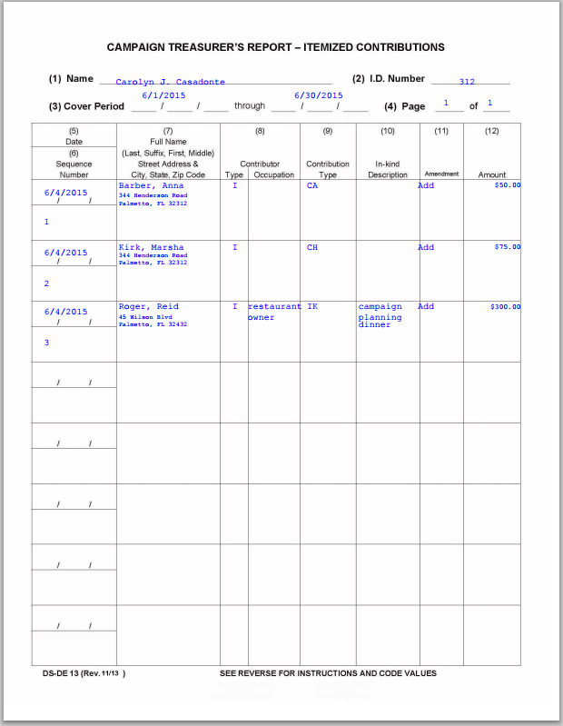
First, there’s a summary page
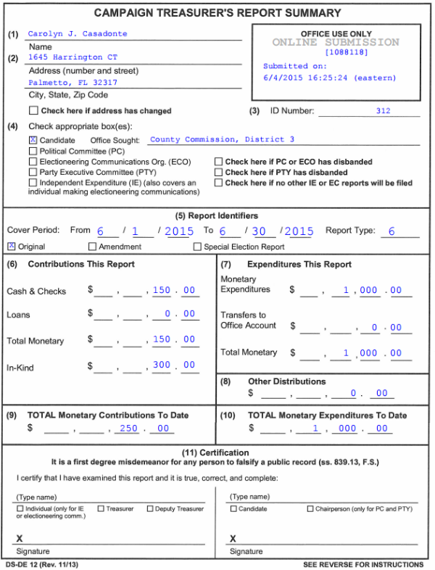

Then, an itemized list of contributions

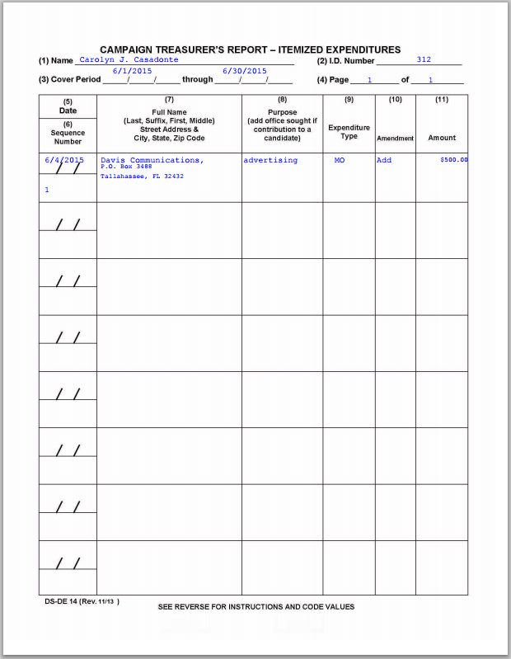

Next, a list of expenditures

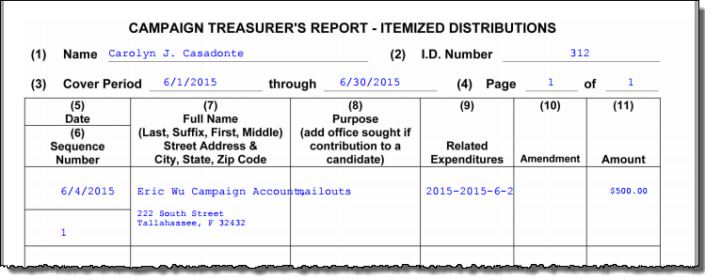
Then, a list of distributions

And finally, a list of fund transfers
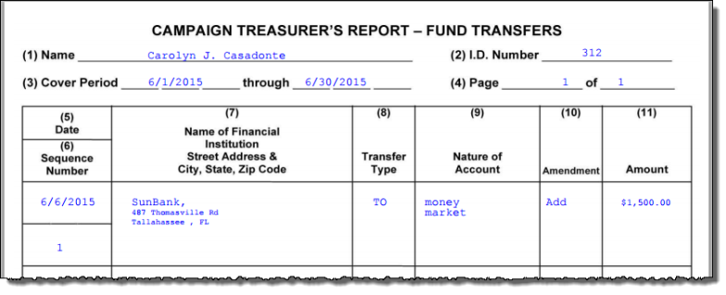

Create Reports Online
- A computer equipped with:
  - An Internet connection.
  - A web browser configured to accept cookies and with pop-up blockers disabled. In this document, the examples shown use Internet Explorer.
  - Adobe® Acrobat® Reader, which you will need to view and print your reports. If you don’t have the Reader software on your computer, you can download it free of charge from:
    - a link in the Campaign Financial Reporting System
or
    - www.adobe.com
  - A printer, if you want a hard copy of the report for your records.
- A candidate ID and password.
This will be provided to you by our office.
Candidates need a new ID each time they run for office, even when they are running for reelection to the same office. Committees also need a new ID for each election.
Committees of continuous existence typically are allowed to keep the same ID, but this varies from county to county. Some counties prefer to assign committees of continuous existence a new ID for each election.
The password can be changed after you log in, if you wish.
- PINs for the candidate and campaign treasurer password.
Two 4-digit PINs will be provided to you by the elections office. You can change the PINs after logging in if you wish.

Getting Started
Log into the Campaign Financial Reporting system like this:
- Type this web address into your browser:
https://www.voterfocus.com/ws/WScand/candidate_pb.php?county=duval
- Press the Enter key on your keyboard or click the “go” icon in your web browser. You’ll then see the Candidate Log In page:
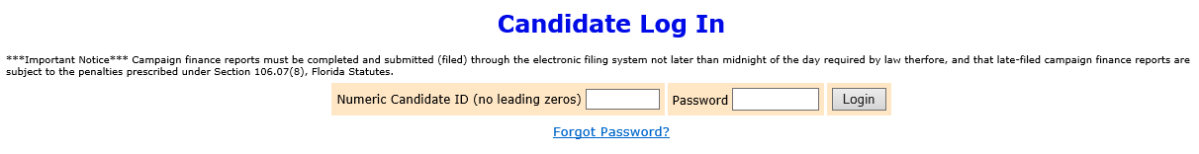
- Enter your candidate ID and password here.
The password is case-sensitive. That means you have to enter the password in exactly the form given to you by the elections office: if a letter is uppercase, you must enter it in uppercase; the same goes for lowercase letters. Your password might also have numbers.
- Click .
The elections office requires that you change your password the first time you log in. After you click Login, you will see the Candidate Reset Password page:
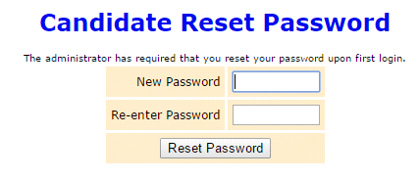
You’ll need to enter the same password in the Re-enter Password field to confirm the new password.
Enter a new password in the New Password field.

The password must be at least 8 characters-letters and/or numbers and is case-sensitive. Do not use common words or part of the user ID. Enter a new password in the fields and then click Reset Password. On the Candidate Log In page, re-enter your candidate ID and your new password and click Login again.
It’s advised that you change your PIN numbers also.
If you are ever unable to login, use another browser to login or clear your cache and cookies in the browser.

Campaign Financial Reporting System Main Page
This is the main page of the Campaign Financial Reporting System. It shows the reporting periods for the campaign. We call this page the Report List.

Election
Your candidate ID
Office or issue
Your name

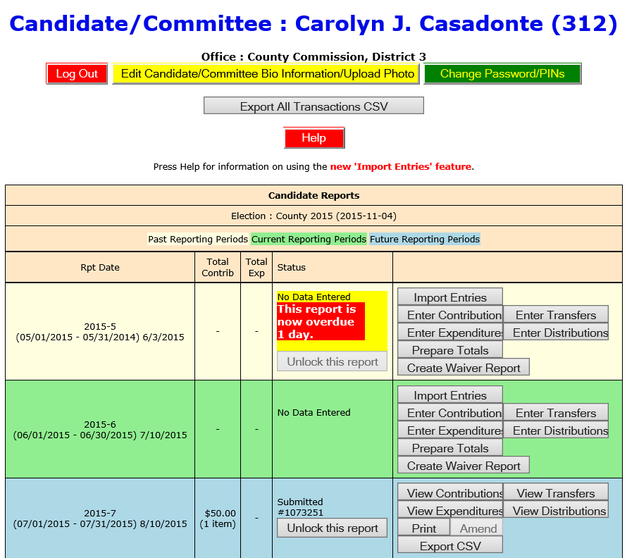

Time periods when financial reports are required.
Colors indicate reporting periods:
(beige)
(green)
(blue)
The reporting periods are color-coded to help you choose the correct period for reporting data.
The past and future reporting periods are locked to prevent you from inadvertently entering current data into a past or future report. If you need to enter past or future data, you can easily unlock the report by clicking .
The colors of the reporting periods switch automatically at midnight on the due date of the current report.

If any of your reports are overdue or the due date is less than 10 days away (that is, 9 or fewer days from today), you’ll see a message like this at the top of the page:
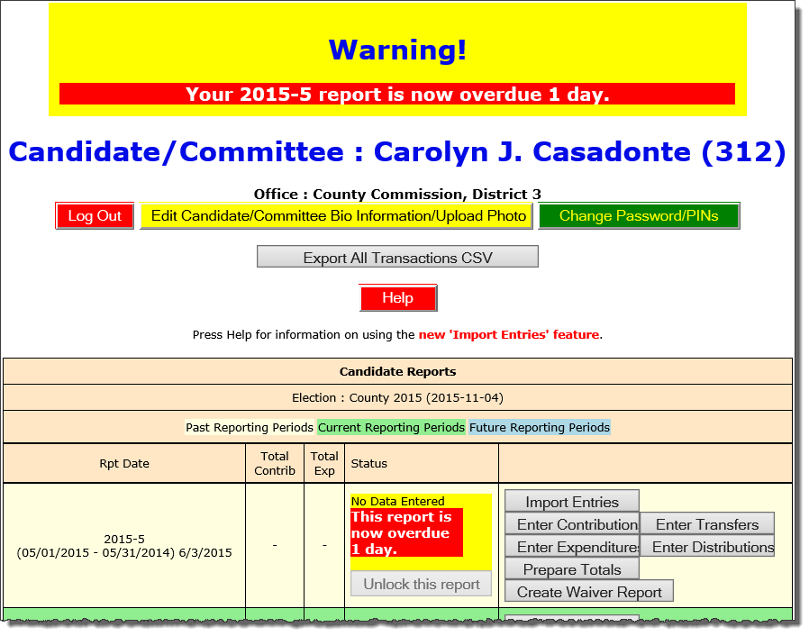

Note: After 180 days, overdue reports are no longer highlighted as late.
If a report is overdue, you need to take immediate action to file the report.

Current Reporting Period

Command buttons for entering data.
We’ll look at these more closely on the next page.
Expenditures so far
Name of reporting period
Contributions so far

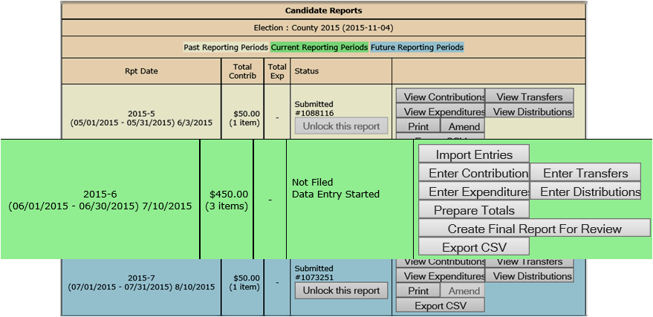

Status of the report.
In this example, the candidate has started entering some of their contributions for the current reporting period, but hasn’t entered their contributions or submitted their report yet to the elections office.
Date when report is due
Start and end dates of reporting period

Command Buttons
If you use campaign finance reporting software like Campaign ToolBox™, you can import contributions and expenditures directly
from that application.
Page 30 explains how.

To manually enter contributions and expenditures, click here.

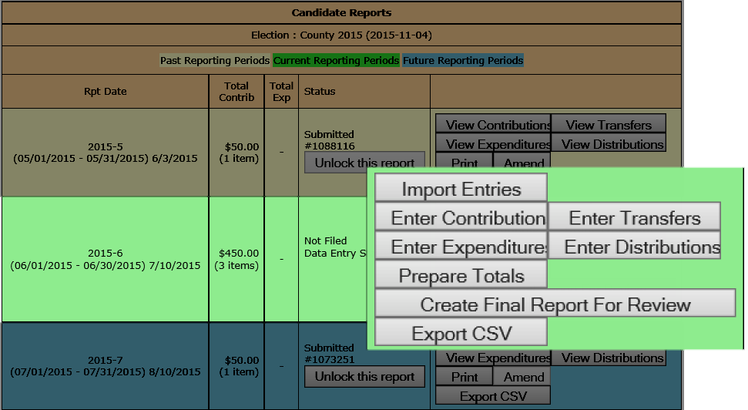
Click here to manually enter fund transfers and distributions.
We’ll talk more about manual entry on the next page.

Submit your report to the elections office.

Create and view a draft copy of your report for this period prior to submitting to the elections office.
Create a spreadsheet of the contributions and expenditures entered in this reporting period.

View and Maintain Contributions
Click
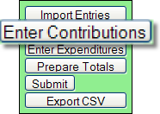to bring up a list of the contributions recorded so far:
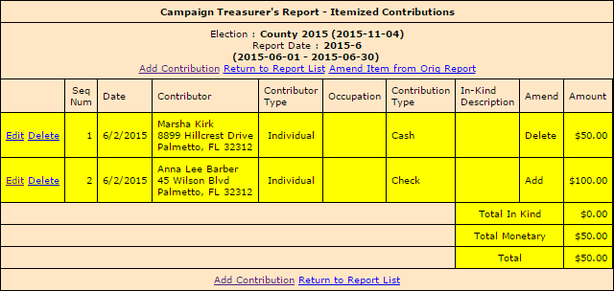
The Totals rows show you a breakdown of In-Kind and Monetary contributions along with the combined total.
Return to Report List Takes you back to the list of reporting periods.
Delete lets you delete the contribution altogether.
Edit lets you modify details on an existing contribution.

Click Add Contribution to bring up the
form for entering contributions.

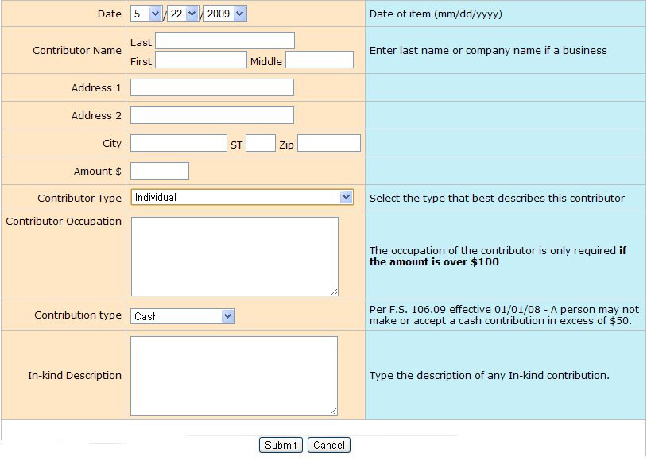

Add a New Contribution

Most of the entry fields are self-explanatory. The blue column has tips on what’s required.
If the contributor is an organization rather than an individual, enter the organization name in the Last field.
And leave the First and
Middle fields blank.

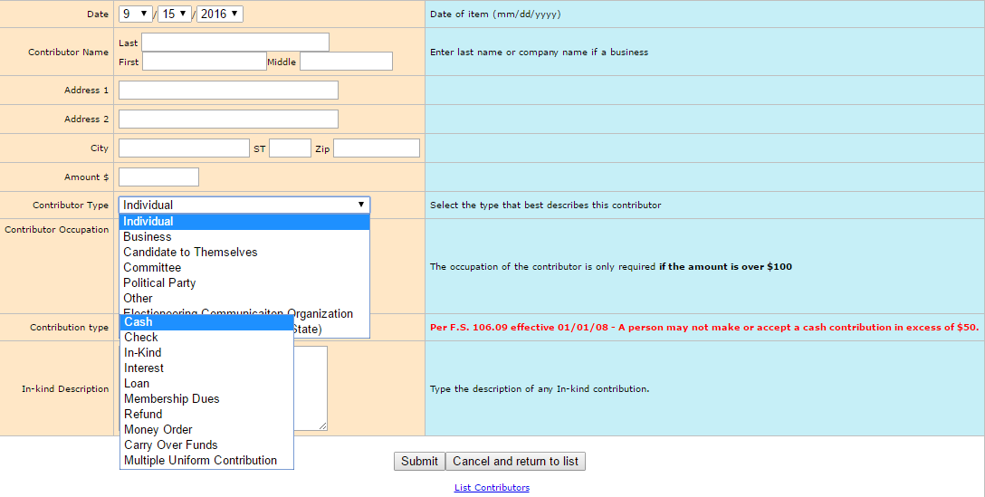
When you’ve completed the form, click Submit.
If the system says you’ve omitted required information, you must provide it before the contribution can be saved.
After the contribution is saved, you’ll get another blank form where you can add the next contribution.

Click Cancel and return to list when you’ve saved the last contribution you want to add right now.

- Specific occupation or business type is required. Business owner, businessman or woman is unacceptable.
- Contributors with protected addresses may list a PO box or an office address. Do not manually enter “Protected.”
- Contributions listed on report must show only one contributor. If check is from a joint account, person that signed check is the contributor.
- Contribution date is day received in hand.
- Electronic contribution date is the day it goes into the campaign account.
- A candidate’s business may only give up to the $1000 maximum.

CONTRIBUTOR AND CONTRIBUTION TYPES
Contributor Type | Abbreviation on Report
Individual | I
Business | B
Committee | C
Political Party | P
Other | O
Electioneering Communications Organization | E
Political Committee (Federal or State) | F
Candidate to Themselves | S

Contribution Type | Abbreviation on Report | What it Means
Cash | CA | Cash or cashier’s check
Check | CH | Traditional paper check, wire transfer, PayPal, credit card, or another type of electronic funds transfer (Enter the total amount of the contribution in Contributions and enter fees in Expenditures)
In-Kind | IK | An item of value other than money or volunteer services.  In-kind Description: Enter a specific description of the in-kind contribution. Example: Food and beverage
Interest | IN | Money earned on campaign or interest-bearing accounts
Loan – Use this when candidate loans money to campaign | LO | Money loaned to the campaign rather than given outright
Membership Dues | DU | Membership dues regardless of the form (cash, check, etc.)
Refund (A refund of a contribution is not an expenditure. (See Opinion 94-13) | RE | Bad checks or contributions returned (in whole or in part) to the contributor. This includes repayment of loan to candidate.  Refunds must be entered as a negative amount.
Money Order | MO | Contribution made by money order
Carry Over Funds from Previous Campaign | CO | Only Candidates may use this
Multiple Uniform Contributions | MU | Only Political Committees may use this

Add A New Expenditure
Click
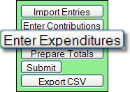to bring up a list of the expenditures recorded so far:
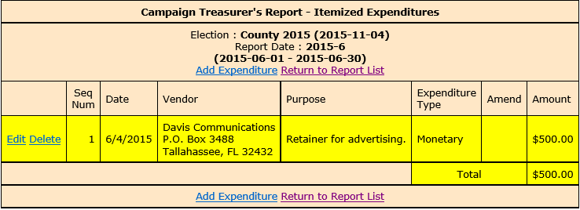

Takes you back to the Report List.
Click Edit to modify details on an existing expenditure.

Click Delete to remove the entry altogether.

Click Add Expenditures to bring up the
form for entering expenditures.

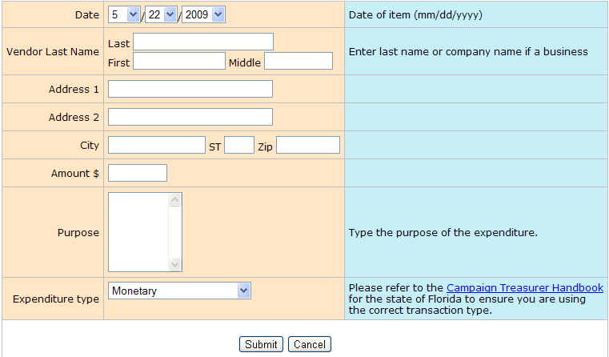
And leave the First and Middle fields blank.

If the vendor is an organization rather than an individual, enter the organization name in the Last field.

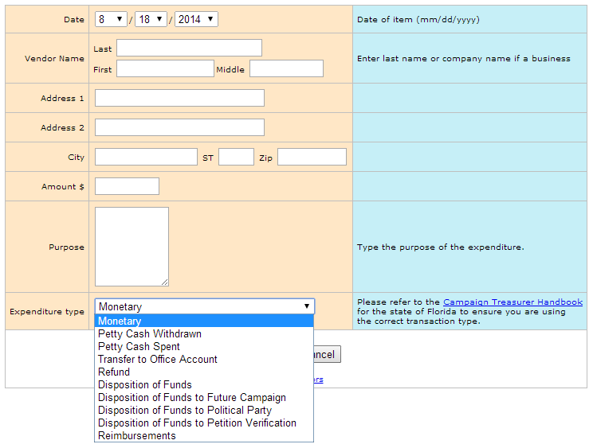
Not sure which Expenditure Type to choose?
Click this link to the Dept. of State website for more information.

About Petty Cash
In Expenditure Type, notice that there are two types for petty cash:
- Use Petty Cash Withdrawn when withdrawing funds from the campaign account for petty cash. This will add an expenditure of the entered amount to your report.
- Use Petty Cash Spent to record an expense out of petty cash.
Petty Cash Spent does not add an expenditure to the report because the expenditure was already recorded as Petty Cash Withdrawn.
It’s important to keep accurate petty-cash records so your final report will balance.
When you’ve completed the form, click Submit.
After the expenditure is saved, you’ll get another blank form where you can add the next expenditure.
Click Cancel when you’ve saved the last expenditure you want to add right now.

EXPENDITURE TYPE
Expenditure Type | Abbreviation on Report | What it Means
Monetary | MO | General expenditure type used when a specific type does not apply. This includes bank charges and any fines or fees.
Petty Cash Withdrawn | PW | Petty cash withdrawn during a reporting period. Petty cash expenditures are realized when the funds are withdrawn for petty cash. This amount will be included in the expenditure totals for the reporting period.
Petty Cash Spent | PS | Petty cash spent during a reporting period. Expenditures made from petty cash are not required to be reported individually. This amount is NOT included in the expenditure totals for the reporting period; list the lump sum of petty cash spent for the current reporting period for information purposes only.
Refund (A refund from a vendor is not a contribution) | RE | A refund of money from a vendor for overpayment of services rendered or refund from other source. Refunds must be entered as a negative amount. (Returned check fee is a monetary expenditure, not a refund)
Disposition of Funds | DI | Pro-rata refunds to contributors, repayment of loan to candidate, donations to charitable organizations, donations to the State general revenue fund, or the return of matching funds to the State.  Disposition of Funds expenditures are for use by candidates only and are only used on Termination Reports. They are not part of the Monthly Total Monetary amounts.
Disposition of Funds to Future Campaign | DF | Used on Termination Report only (state candidates only (F.S. 106.141(6)(b))
Disposition of Funds to Political Party | DP | Used on Termination Report only
Disposition of Funds to Petition Verification | DV | Used on Termination Report only
Reimbursement | RM | Used when making a reimbursement.  **You must also do a DISTRIBUTION if you reimburse someone. The distribution will show WHY you are reimbursing the person – where did they spend their money thereby causing you to have to reimburse them**
Transfer to Office Account | TO | Funds transferred to an office account when the candidate has been elected.
A street or mailing address must be entered for web vendors. Website address is unacceptable.

Contributions and Expenditures Overview
If you enter a contribution or expenditure outside of the range of the reporting period you are working with, they system will automatically try to find a reporting period that contains that date you are reporting.
If a report for that range is found, the system will let you know.
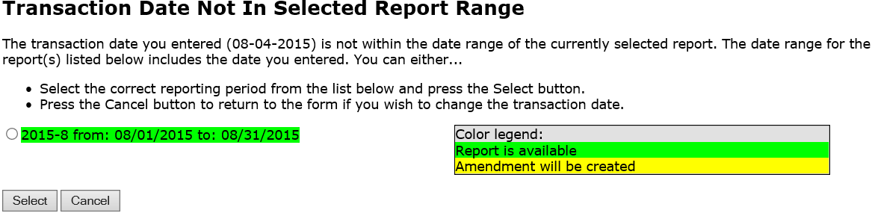
Click the report that you would normally have filled the transaction under and then click Select.

If the contribution or expenditure date falls within the date range of a report that has already been filed, you can add the contribution or expenditure to the report and file an amended report in one easy step.
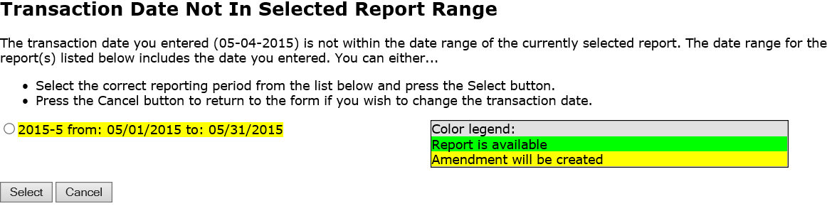
Click the report that you would normally have filled the transaction under and then click Select. A confirmation message will appear letting you know that the amended report has been filed.

If no report exists that includes the date you are trying to report on, the system will let you know that too.
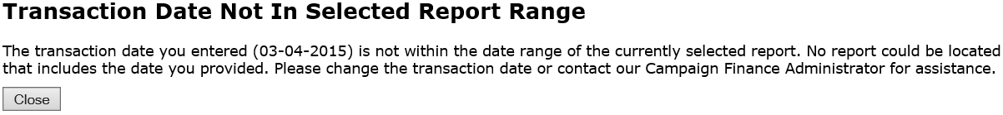
Click Close and then either change the transaction date or contact your county Campaign Finance Administrator for assistance.

Preview a Report
Previewing of reports isn’t required. But it’s a good idea to preview the report before you submit it, to catch any data entry errors, missing transactions, or other anomalies.
You can preview a report as many times as you like, make changes, and preview it again until you are confident it is correct and complete. Then you can submit the finished report to the Supervisor. A report can be changed only if it is before the due date and the Campaign Finance Administrator rejects the report. It can then be resubmitted.

Previewing a report DOES NOT submit the report
to the Supervisor.

To preview your report so far:
Click
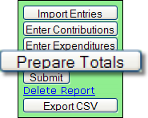 to bring up this page:
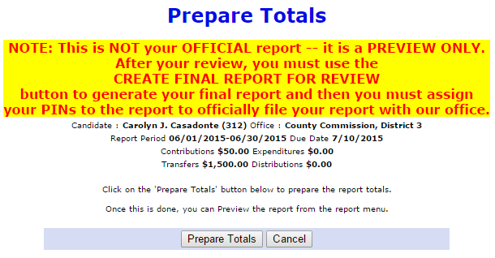

Click to total the contributions and expenditures for this reporting period. You’ll be returned to the Report List, which now has a banner like this:
If you haven’t installed Acrobat Reader
on your computer, you must do it now.
Click the Acrobat Reader icon
to go to the download site.
Click in the banner to bring up a PDF of your report.

Check the draft report carefully to verify everything is correct and complete.

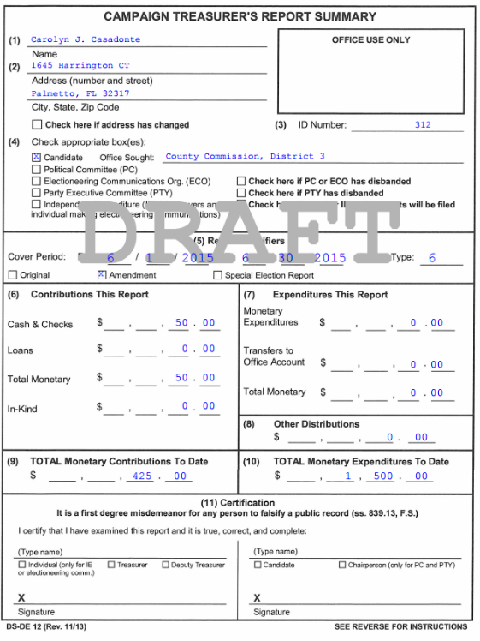

The preview version of the report has a DRAFT watermark on each page.
The elections office cannot accept a draft report. You must submit a final report.

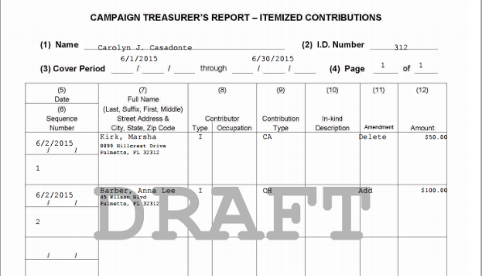

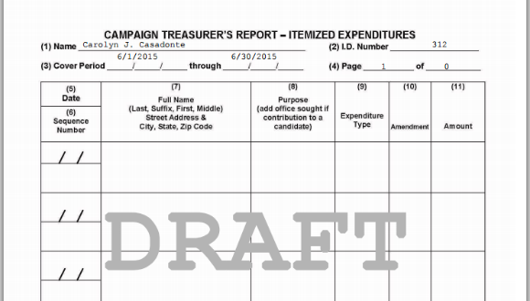

Forgot to add a contribution or expenditure? That’s OK! You can continue to add them after your preview.

On the Report List, notice that the Prepare Totals button is now labeled Preview.
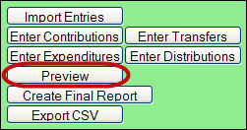

You can click Preview at any time you want to look at the report. If transactions are added, the button label will switch back to Prepare Totals, which means you need to total the new transactions into the report before you can preview it again.

Record a Distribution for Reimbursements
A transaction is a distribution only if it is a:
Credit Card Payment—Linked to the expenditure that represents payment of the credit card bill on which the purchase appears. Only statewide candidates may use this type of distribution.
Each purchase made with the credit card will be itemized under and linked to the expenditure that represents payment of the credit card bill on which the purchase appears. The credit card may be used only for travel-related expenses.
Prepaid Distribution—Reserved for up-front, lump sum payments to be disbursed to different entities at a later date. (For example, payment to a media consultant who then makes disbursements to newspapers and television stations.) Related entries under will be reported and linked to the expenditure as they occur.
*Reimbursement—Reimbursement for authorized expenses made in connection with the campaign. (For example, Candidate Smith paid for printing of campaign signs with his own money. A check to reimburse him for the cost would be recorded as a Reimbursement.
When the campaign treasurer issues a campaign check to an individual who has made authorized purchases on behalf of the campaign using PERSONAL funds, it is necessary to record the expenditure as an RM and create a DISTRIBUTION page .
To record a distribution:
1. Click Enter Distributions (shown below) to open a page with descriptive requirements for a distribution transaction

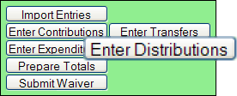

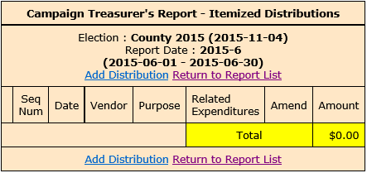
2. Click 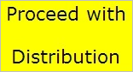 to see this page:

3. Click Add Distribution to bring up the form for entering distributions.
4. If the entity receiving the distribution is an organization rather than an individual, enter the organization name in the Last field.
Enter the date the distribution occurred. This date does not have to be within the current reporting period.
Enter the amount and the purpose of the distribution. If the distribution is a contribution to a candidate, be sure to indicate the office they are running for.
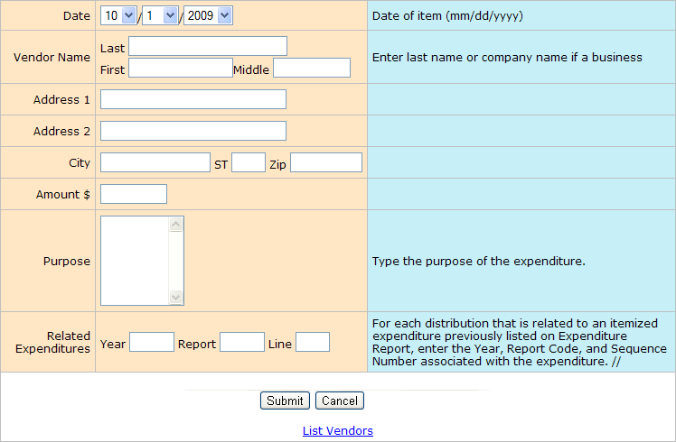
If the distribution is related to a previously reported expenditure, enter:
- The year when the expenditure was reported.
- The Report Type from the first page of the report (example, M4).
- The Sequence Number (from the first column of the report’s expenditures page.
5. When you’ve completed the form, click Submit to save the information. After the distribution is saved, you’ll get another blank distribution form.
6. Click Cancel when you’ve saved the last distribution you have right now. You’ll see the distributions you added highlighted in yellow..

7. The total of those items must equal the amount that was reported on the original expenditure line.

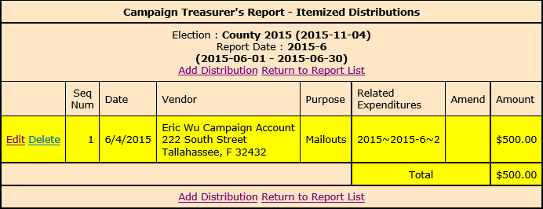

REIMBURSEMENT EXPENDITURES/DISTRIBUTIONS EXAMPLE
Two people were issued checks in the example below. They paid out of pocket for campaign expenses. This is recorded in expenditures as a “Reimbursement.”
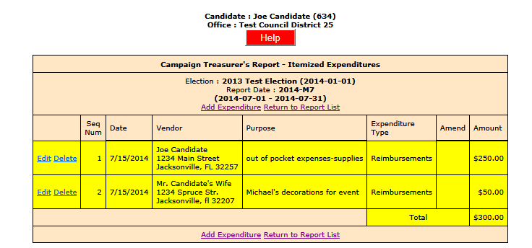
The DISTRIBUTION will contain the itemized list of vendors who were paid with personal funds. The total of those items must equal the amount that was reported on the original expenditure line.
The next three form pages add up to $250.00 and that total appears on Expenditures, Seq. Num. 1:
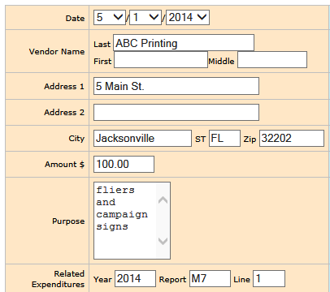
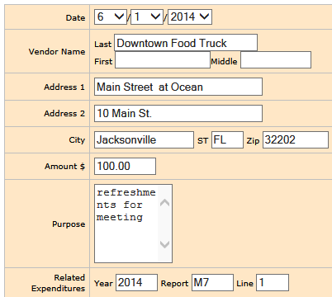
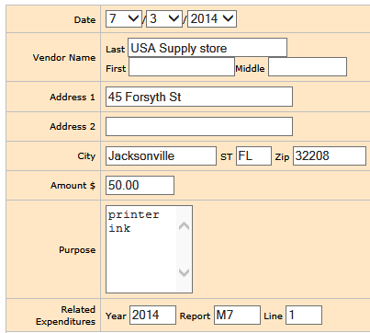

The next form page adds up to $50.00 and that total appears on Expenditures, Seq. Num. 2:
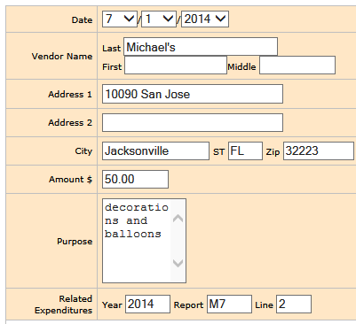

This is what the completed distribution page will look like:
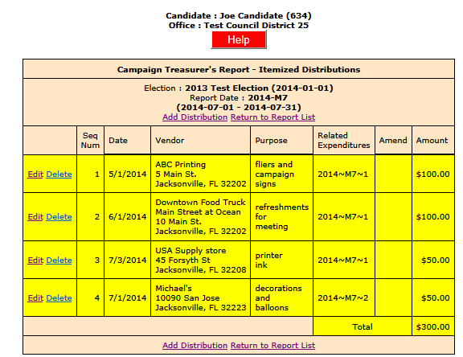
The page in the final submitted report (pdf) will be entitled Itemized Distributions
(Form DS-DE 14A):
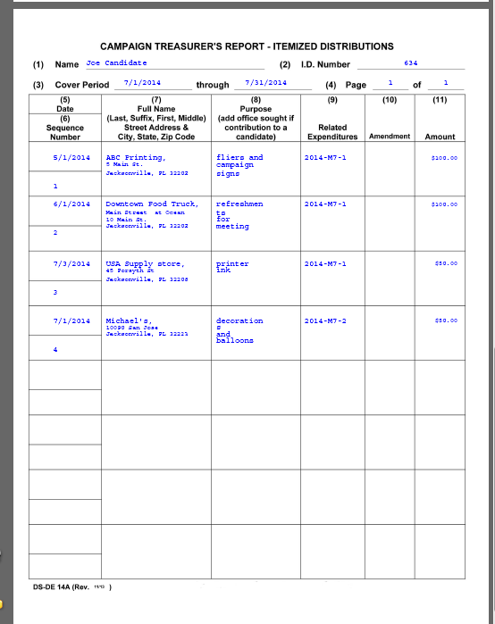

Transfer Funds
Fund transfers are typically used only by candidates for state and federal offices.
They are used to report the transfer of funds between the primary depository and separate interest-bearing accounts.
Click
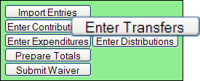 to bring up this page:
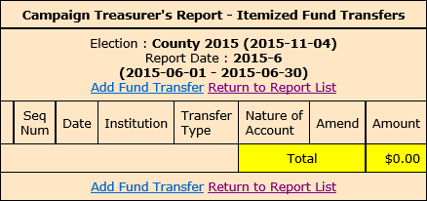
Click Add Fund Transfer to bring up the form for entering transfers.

Enter the financial institution where the account is held.
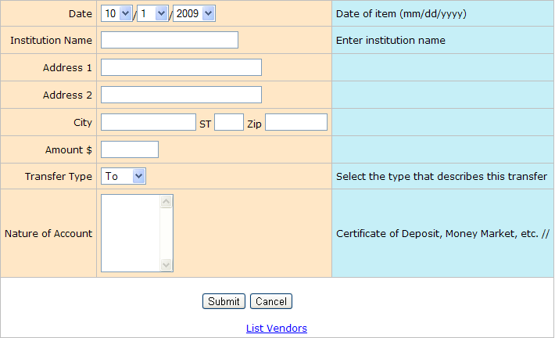

Select one of the following:
To, if the transfer is from the campaign account to the institution account.
From, if the transfer is from the institution account to the campaign account.
When you complete the form, click Submit to save the information. After the transfer is saved, a blank form opens to enter another transfer.
Click Cancel after you save your last transfer. Transfers are not shown on the Reports List because the funds are simply moved within the campaign or committee, rather than expended or distributed elsewhere.

Import Data from Campaign Application
Import File Requirements
The system can import any file that meets the Division of Elections Campaign Finance Reporting File Specifications:
Dos.myflorida.com/elections/candidates-committees/campaign-finance/filing-campaignreports/
For a list of State-approved software vendors for electronic filing, see:
Dos.myflorida.com/elections/candidates-committees/campaign-finance/filing-campaignreports/vendors/
Candidates or committees using campaign finance reporting software, such as Campaign ToolBox™, can import contribution, expenditure, distribution, and fund-transfer data from a file created by the application directly into the Campaign Financial Reporting system.
When you import data from a file, the transactions are added to the report you are working in. Be sure to review the report prior to submission to verify the data matches what you intended to import and make any adjustments manually.
Important: When you import a file from your campaign finance reporting software if there are existing entries in the Campaign Financial Reporting system for the reporting period you are importing entries in to, these entries will be replaced with the information from your file.
Note: Before importing a file, verify that you have not manually entered contributions, expenditures, distributions, or fund-transfer data into the Campaign Financial Reporting system. If so, verify that these entries also exist in your campaign finance reporting software
Current Reporting Period
- On the main page, locate the row for the current reporting period (look for the green row) and click .
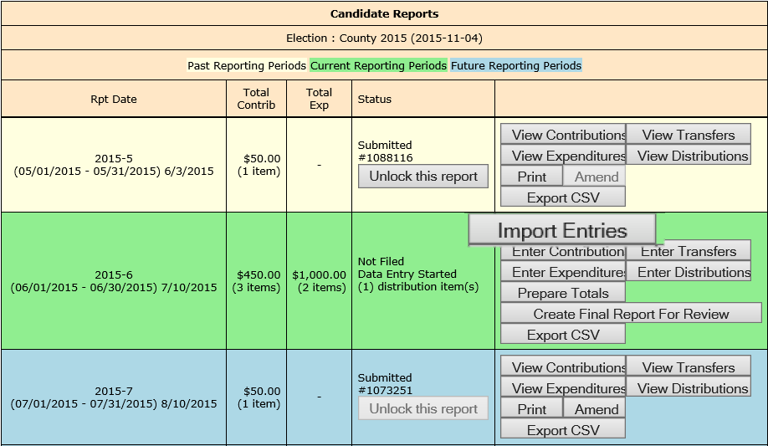
Import Entries brings up the Upload Report page.
Current reporting period is shown in green.
- On the Upload Report page, click and find the file you want to import. Then click .
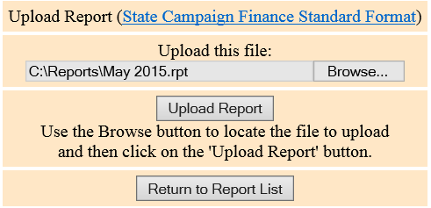
Name of file to import.

Click Upload Report to import the file into the system.
You’ll see a display of the transactions imported from the file, as in this example:
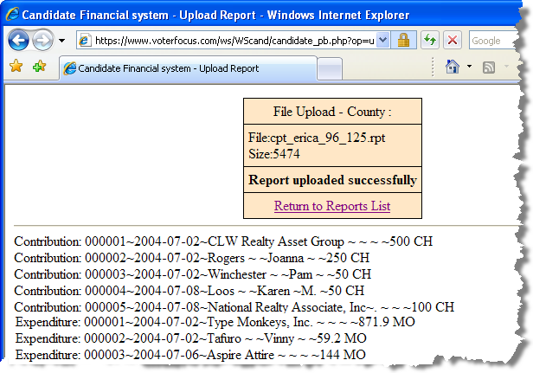
Contributions

Expenditures
- When you’ve finished importing entries for the reporting period, preview, and submit the report.
Past and Future Reporting Periods
• Past reporting period—If you already submitted the report for the past reporting period, you’ll need to unlock it and create an amendment. Then you’ll need to unlock the amendment and follow the Import Entries instructions in the previous procedure.
• Future reporting period—Unlock the reporting period and follow the Import Entries instructions in the previous procedure.

Submit a Report
Important: Make sure you have entered ALL contributions and expenditures correctly before you click Submit Report. Clicking Submit Report closes the report.

Once you do this, the report cannot be changed, although it can be amended. See Change a Filed Report for more information.

The steps you take to submit a report depend on whether your county requires a hard copy of the report signed by the candidate and treasurer or requires submission of reports “signed” by the electronic PINs of the candidate and treasurer.

Submit Electronic Reports
- To finalize the report, click Create Final Report For Review to display instructions

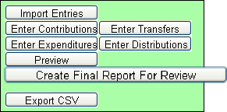

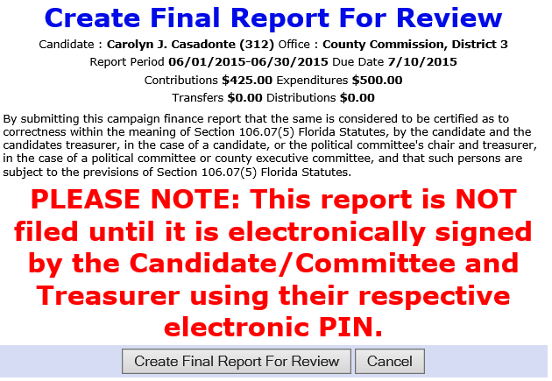

2. When you finish your entries for this reporting period and you are ready to file, click Create Final Report For Review. The Electronic Signature PINs page opens with a reminder that the report is not yet submitted followed by an online view of the report

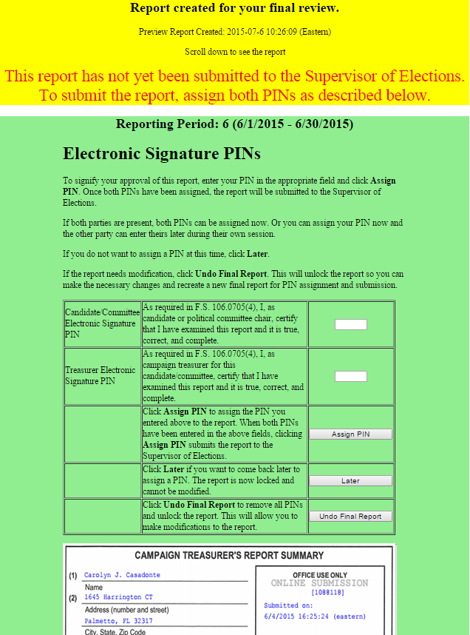

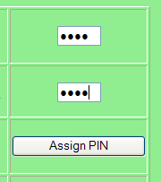
3. You can do the following:
• Enter both PINs in the space provided and click Assign PIN to submit the report to the Supervisor of Elections.
Enter Candidate’s PIN

Then, click

Enter Treasurer’s PIN

- Enter just one of the PINs and click Later to return you to the report list.

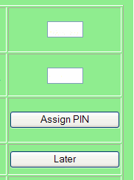
Enter Candidate’s

or

Treasurer’s PIN

Then, click

The message Signature (PINs) Required appears in the report’s Status column and the report is then locked, which means no changes can be made.

4. When the report is ready to be signed with the other PIN, click Assign PIN(s) to
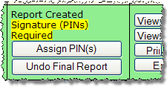
reopen the PIN page.

- Enter the missing PIN and click Assign PIN to submit the report to the Supervisor of Elections.

Note: If you want to remove the PINs and unlock the report so you can make changes, click Undo Final Report.

Review a Submitted Report
The DRAFT watermarks are gone...
and your confirmation number is displayed in the Office Use Only box
along with the date and time you submitted the report.

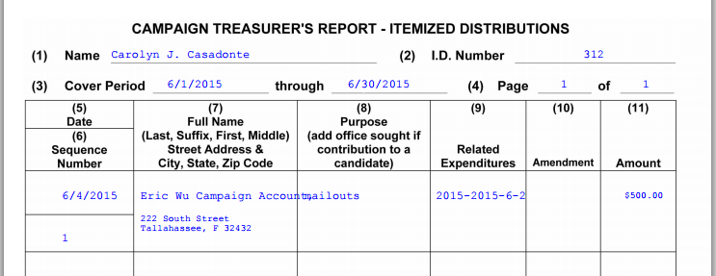
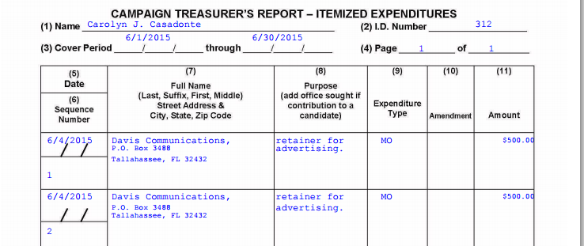
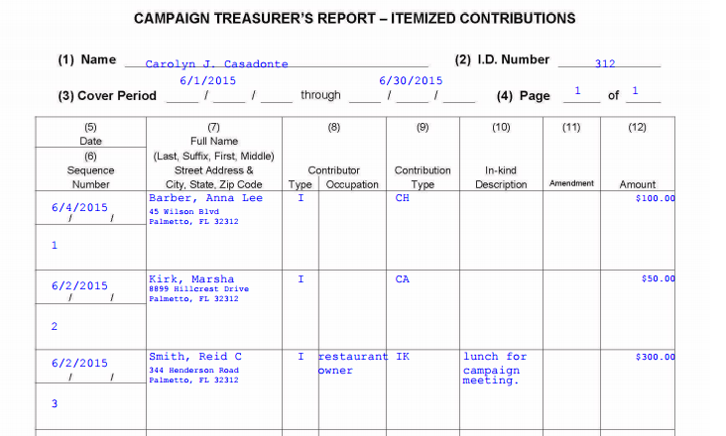
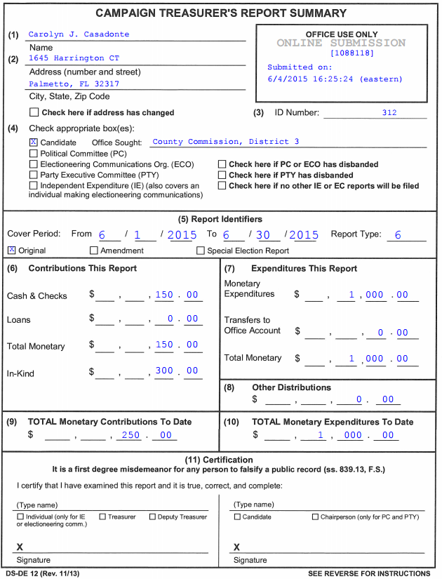

Notice that the Original box is selected in the Report Identifier section.

It indicates that this is the original report for this reporting period.

Should you later file an amendment to this report, the Amendment box will be selected instead.

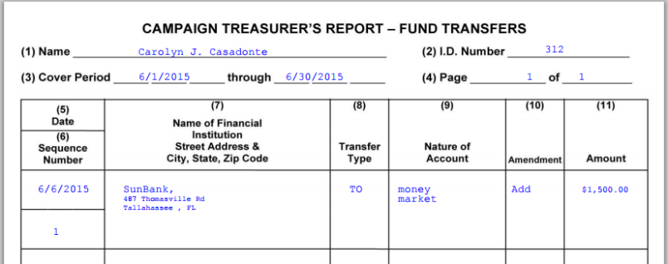

Reports on the Supervisor of Elections Website
Once the Candidate and Treasurer PINs are assigned, an email will be sent to the candidate office letting them know of the submission. The report status will show Submitted. Your report will be reviewed, if possible, and released to the public. Once the report is released, the status will show Received, and the report is available on the website.
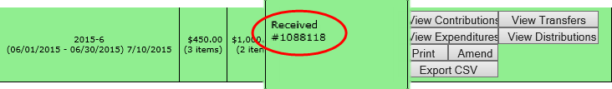
To get to your candidate page, website visitors select your name from the list of candidates running in a selected election.
Election selected here.
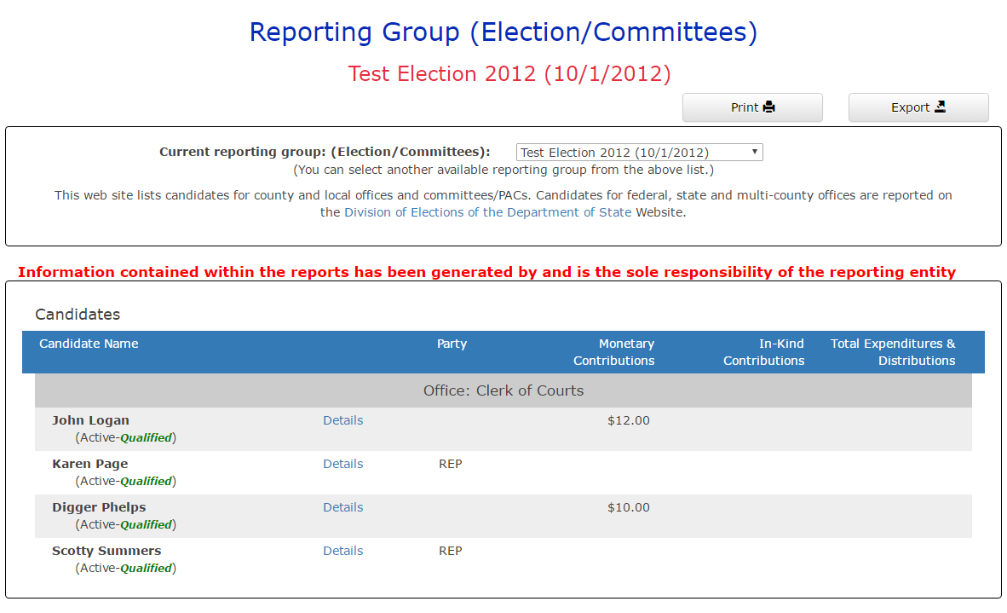
Candidate selected here.
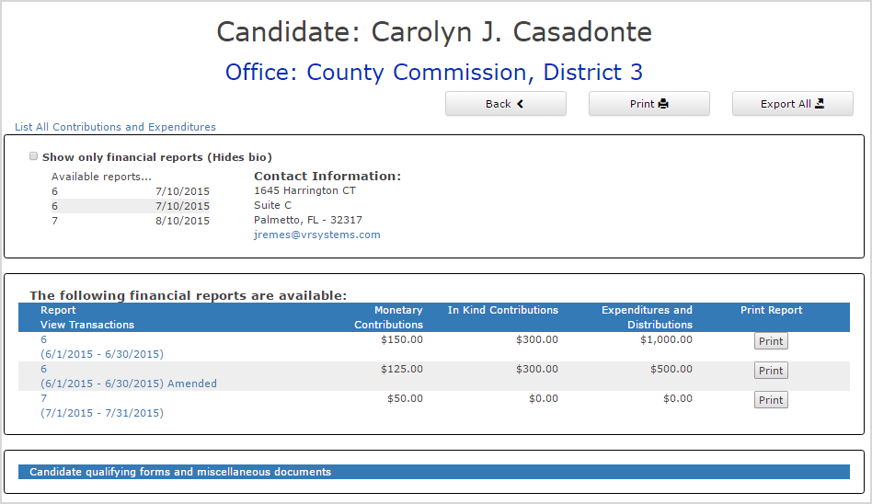
Your candidate page will list all reports that the elections office has released to the website.

Display list of all campaign transactions
The newly received report is listed here.

Website visitors can click the report name in the Report Views Transactions column to bring up a list of all transactions reported so far grouped by type.
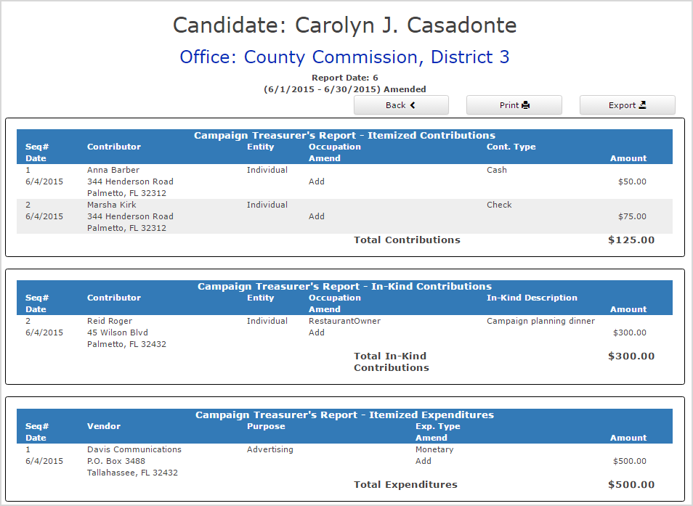
Contributions from persons with protected-address status are not shown in reports. Instead, the notation ***Protected Voter*** will be seen in place of the address. The address must be correctly entered to show as protected. The Campaign Financial Reporting system scans the county’s voter registration database for voters with protected addresses and automatically redacts those addresses from campaign reports, so they cannot be seen by the public or the Supervisor’s staff. If you are aware of a contributor with a protected address who is not in your local county’s voter database, please advise your Supervisor of Elections.
NOTE: If you believe that a contributor has / or should have a protected address (ie., law enforcement, fire department, judicial, state attorney office related), the contributor may list a business address or P.O. Box as an alternative address. You may not “manually” protect the address in this way:
Name
Protected
Jacksonville, FL

An address is always required. Entering data in this way may result in an audit notification.

Save a Copy of the Report
A copy of all the reports you file will continue to be available on the Campaign Financial Reporting system. If you want to keep a copy on your local computer, just save the PDF to a folder on your computer or network.
To save copy of the report to your computer:
Click
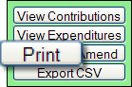 to display a PDF of the report in Acrobat Reader.

Click . Save the PDF to a location on your computer or network. You might consider giving the copy a different file name; names assigned by the system are cryptic.

Change a Filed Report
After a report has been submitted to the elections office, you cannot change it, but you can make an amendment. An amendment is a separate report for the reporting period. On the amendment’s first page, you’ll see a checkmark in the Amendment box.
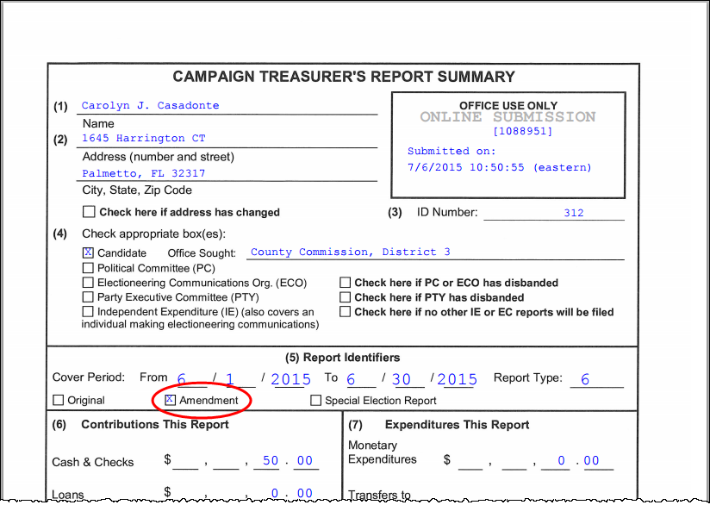
The Amendment box is automatically checked when you create an amended report.
You can amend a report any time after you submit it and it has been received. A report submitted prior to the due date may be rejected by SOE at the request of the candidate / treasurer in order to make corrections, hence avoiding the amendment procedure.
You can create an amendment to a report for any reporting period. The steps to do this are the same for all reporting periods with one exception; for past reporting periods, you must first unlock the report following the instructions beginning on page 44.
To create an amendment to a report in the current reporting period:
In the current reporting period (the green row), click 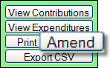
to bring up this page:
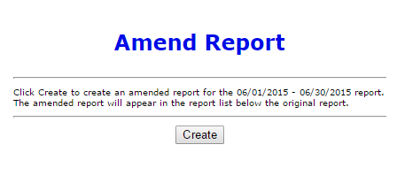
Then click .
When the Report List reappears,
notice that there’s now a new row for the current reporting period.
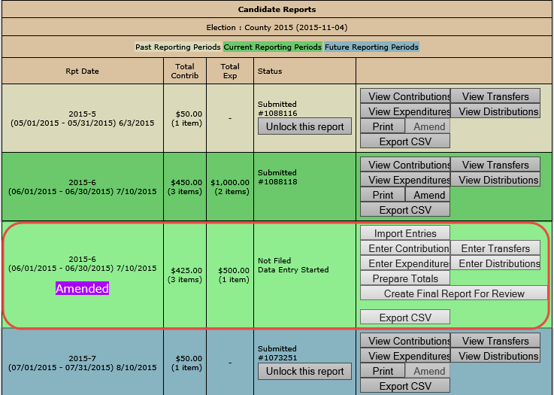
Enter the new data using these buttons, just like you did on the original report.
To create an amended report, you can:
- Manually enter new contributions and expenditures.
- Import new contributions or expenditures.
- Change or delete items listed on the original report.
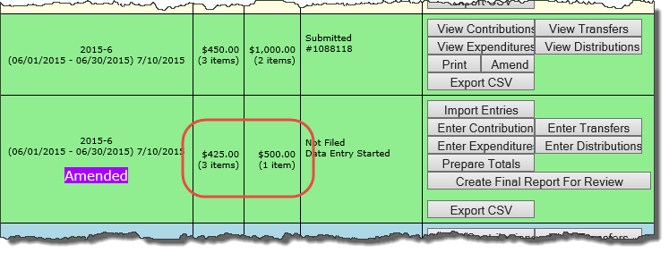
The totals of items on the amended report are displayed just as they were for the original report.
When you are finished entering items, preview the report and submit it to the elections office. You’ll see a new confirmation number for the amendment.
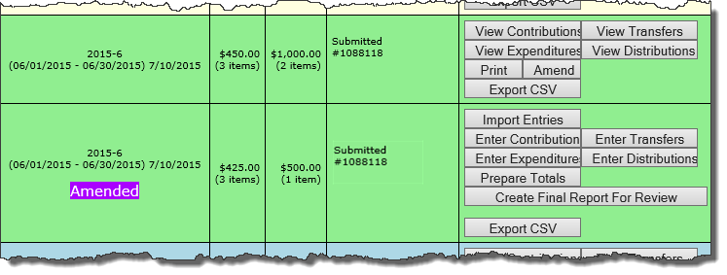
If you need to change a report after submitting the amendment, please call our office.

To create an amendment to a report in a past reporting period:
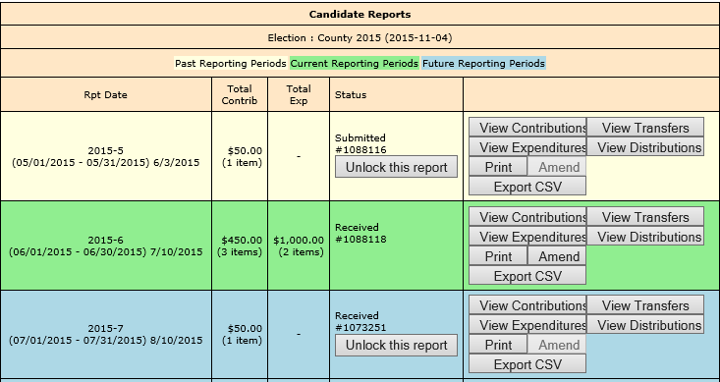
In the past reporting period (the beige row), click Unlock this report.

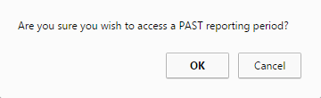
When the confirmation message appears, click OK.

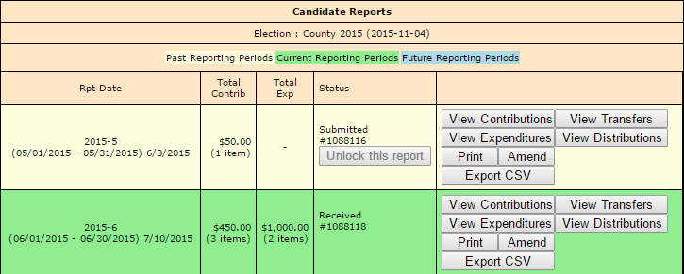
The Amend button for the past reporting period becomes available.

Click “Create”

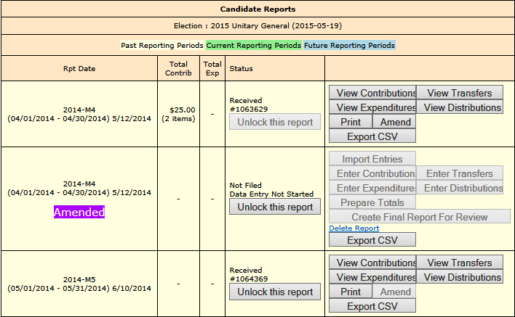
A new row appears for the amended report. You will need to click Unlock this report once again.

Once the amended report is unlocked, you will be able to use the buttons on the right to enter the new data just as you did on the original report.
When you are finished entering data, preview the report and submit to our office.

Change or Delete an Item on an Original Report
First, verify that the status of the original report is Received:
To change data that was entered on the original report, the original report’s status must be Received.
To change a contribution or expenditure:
In the current reporting period (the green row), click
to bring up this page:
Then click .
When the Report List reappears,
notice that there’s now a new row for the current reporting period.
Enter the new data using these buttons, just like you did on the original report.

On the next page, click Amend Item from Orig Report.
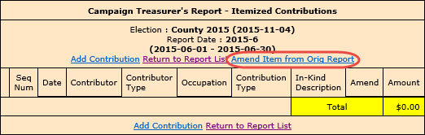
to bring up a list of items (for example, contributions) reported in the current month:
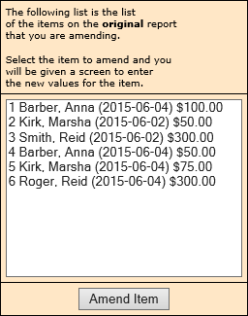
To change an item, highlight it.

Then click Amend Item.
Highlight the item you want to change and click to bring up the detail page for the item.
Type the changes where they are needed. If you want to delete the contribution or expenditure, simply zero-out the Amount field. When you’ve finished, click .
This page shows the details for the item as they were entered into the original report.
To change an item, just make your changes in the appropriate fields.
To delete an item, type a zero (0) in the Amount field.
When finished, click Submit.

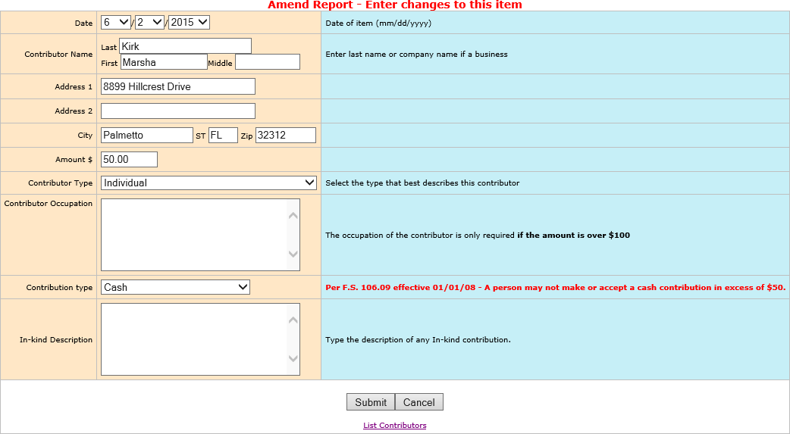
On the next page, you now have two entries (in yellow) representing the changed item:
  - The first entry deletes the item as it was filed in the original report. (Notice the word Delete in the Amend column.)
  - The second entry adds the item with the changed values. (Its Amend column says Add.)
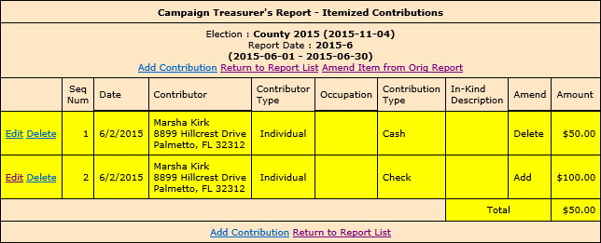
Deletes the original item.

Adds the changed item in its place.
In the example here, we changed the contribution amount from $50.00 in cash to $100.00 by check.
This completes the change to the original item. From here, you can change another item, add a new item, or return to the Report List. You must submit report by same procedures appearing on pages 34-38.
NOTE: Do not delete any entries here. Both items are needed to reflect the desired changes.

Remove an Amended Report
Sometimes we create an amended report that we don’t need.
If you begin creating an amended report, notice that the list of commands on the Report List includes the command Delete Report. To back out of the report, first delete all the transactions you have entered for the amended report. Then, once there are no transactions for the amended report, you can click Delete Report to delete it from the system.

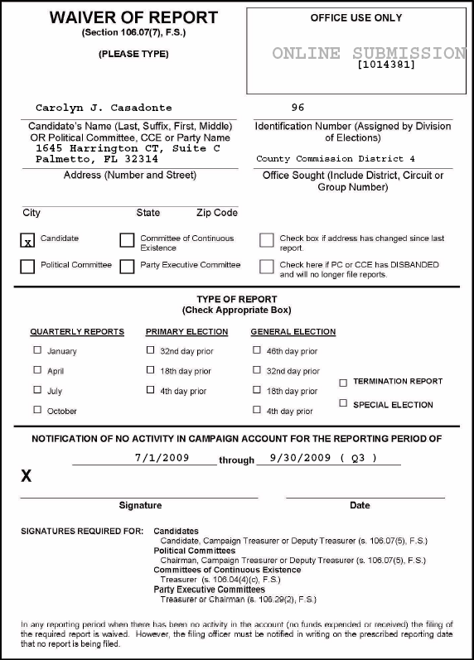
Submit a Waiver
A waiver is a one-page report that you fill out and submit to the elections office to notify
there is no activity for a reporting period. In any reporting period when there has been no
fund activity (expended or received), filing the report is required.

Note: The Create Waiver Report button will not display on the candidate login screen for committees that are set up as Type - Electioneering Communication.
On the Report List, find the reporting period that you want to submit a waiver for.
Click
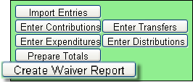

On the next page, click to bring up the Electronic Signature PINs page with a reminder that the report has not yet been submitted.
Note: For committees set up as Type - Electioneering Communication, a waiver will no longer be generated when clicking Create Final Report for Review with no contributions or expenditures applied.
Enter both PINs in the spaces provided and click Assign PIN to submit the waiver to the Supervisor of Elections.

Unlock a Report
Have you noticed that reports for past and future reporting periods have an button?
These buttons prevent you from accidentally entering data for the current reporting period into a past or future period.
If you find that you need to amend a past report or enter data for a future report, click .
For past reporting periods, you’ll then get command buttons for amending the report.
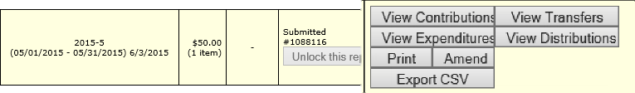
And for future reporting periods, you’ll see the usual buttons for entering data.
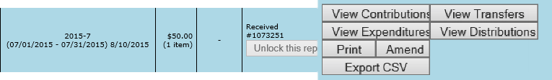

Export Data to a Spreadsheet
The system has two ways to export your financial data to a Microsoft Excel comma-separated values (.CSV) file:
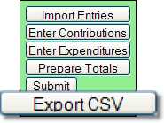 collects all data for the selected report.

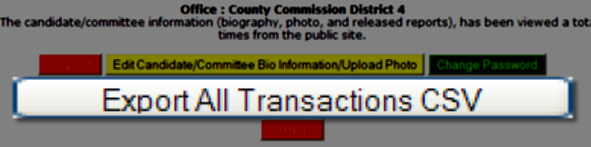 collects all data from all reports in this election.
Both options create a file named CFinExport.csv in your C:\Temp folder.
When you click either button, you’ll see a message asking if you want to open or save the file. You can view the file immediately or save it to a different name and location, if you like.
The spreadsheet file contains this information:
    - Date the item was recorded
    - Whether it’s a contribution (C) or an expenditure (E)
    - Contributor or vendor name and address
    - Contribution type
    - Contributor’s occupation
    - Item type
    - Description
    - Amount
    - Whether the item was recorded in the original report (blank) or an amendment (A)

Campaign End Reporting
On the Report List, you will see a section for the termination report, which is the absolute last report that will be submitted by your campaign. This report states the financial status of your campaign after all contributions and expenditures have been reconciled. It also should also show how any surplus funds were disposed of.
The termination report might not appear in the Report List at the beginning of the campaign, but the elections office will add it to your reporting dates at the appropriate time. Note that it might not be named Termination Report. The elections office can give it any name, such as 2015-Final, like the example here.
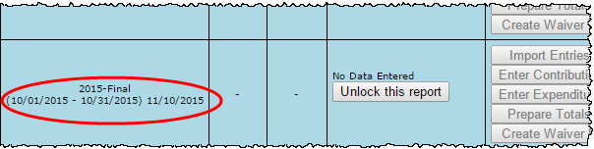
When it’s time to file the termination report, its row will turn green.
To file this report, you will need to add any outstanding contributions and expenditures that haven’t been reported in an earlier report.
If surplus funds remain in the campaign account, the termination report should include an expenditure that disposes of those excess funds. When you enter this expenditure, be sure to select Disposition of Funds for the Expenditure type.
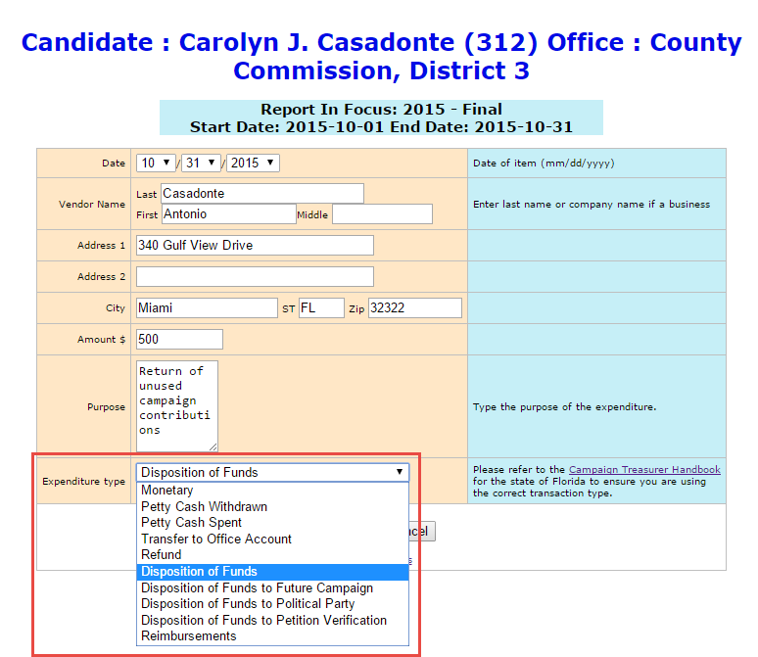
To report on the disposition of surplus funds, select one of the Disposition of Funds options in the Expenditure type field. For a description of each type, see page 17.
Campaigns sometimes confuse Disposition of Funds
and
Enter Distributions.
Remember that Disposition of Funds is a type of expenditure, whereas a distribution is a type of transaction referring back to a previously recorded expense.
When you return to the list of expenditures for the termination report, you will see the item listed, but the amount will not be reflected in the total expenditures for the period. Nor will the amount be included on the Report List—in the Total Exp column—although it will be counted as an “item.” This design is in accordance with Division of Elections requirements.
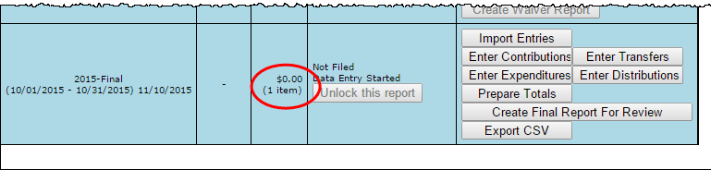
Preview the report and submit it as you have previous reports for the campaign.
When you look at the report, notice that the Disposition of Funds amount is not reflected in box 7 of the Report Summary page.
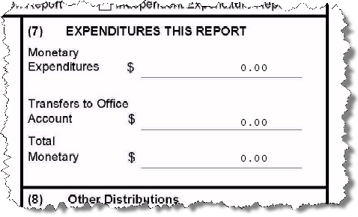
But the amount will be included in box 10 of the Summary Report.
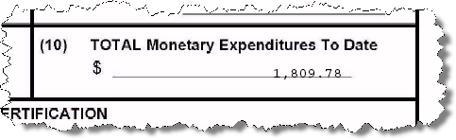
And it will appear on the Itemized Expenditure page with an expenditure type of DI.
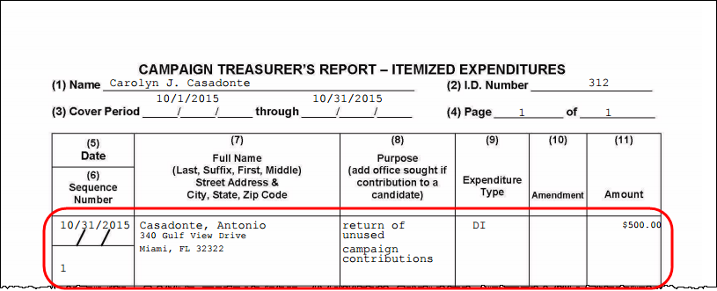

Update Candidate Photo and Bio
You can place a JPEG file, such as a photo, and descriptive text on the page that voters see when they visit the Campaign Financial Reporting system.
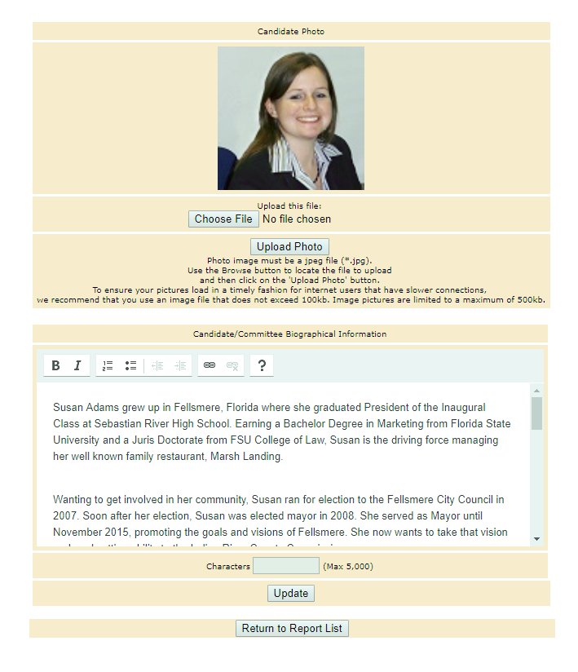
Biographical information
Photo of candidate
A photo and text about the candidate or committee are nice to have, but they are not required. If you don’t provide them, here is what voters will see:
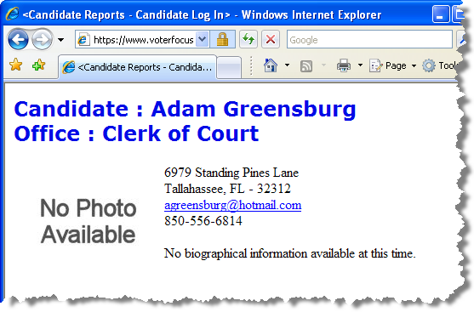
The item in the photo area need not be a photograph. Committees might prefer to show their logo instead. But the file placed in this area must be a JPEG file. That is, the file’s
3-character file extension must be .JPG.
The system won’t accept a JPEG file that’s larger than 500 KB. It’s best to use an even smaller file if you can, because smaller files display more quickly to website visitors than large ones, especially if a visitor has a slow Internet connection.
Note Images with large dimensions (that is, large pixel sizes) might not display properly in certain older browsers.
To enter a photo:
On the main page, click the yellow button.
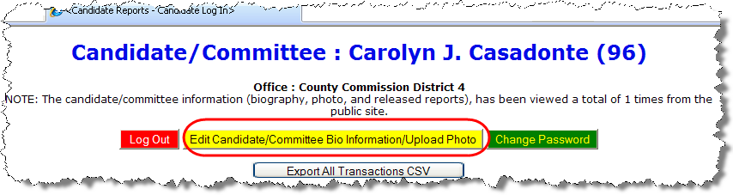
to bring up the Candidate/Committee Bio page:
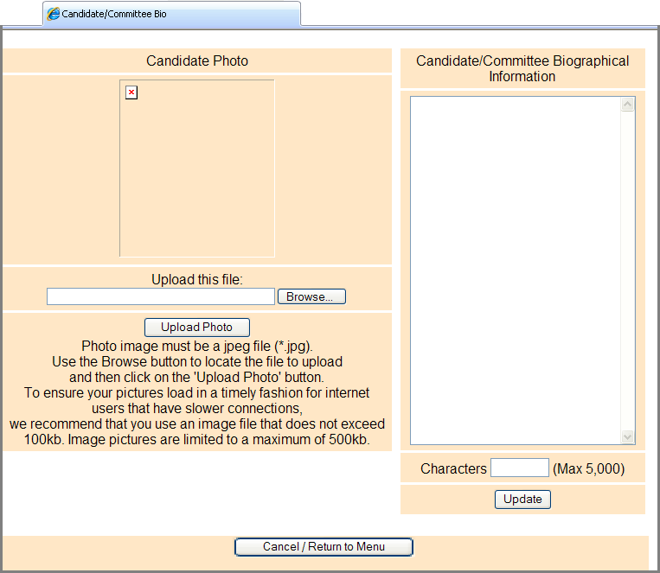
Click Browse and navigate to the JPEG file you want to use. Then click Upload Photo.
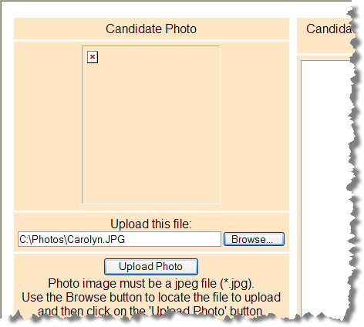
Then click Upload Photo.
The file path will be displayed here.
Click Browse and find the photo file.
When the file has copied to the system, you’ll see this message along with the photo file:
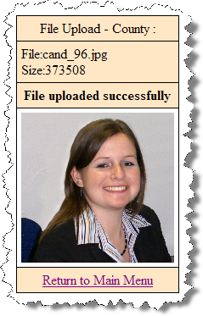
Click Return to Main Menu to return to the main page of the system.
To enter candidate or committee text:
On the main page, click the yellow button.
to bring up the Candidate/Committee Bio page:
In the Candidate/Committee Biographical Information pane, type the information you want to display to voters. You can enter up to 5,000 characters. The system will show you—in the Characters box—how many characters you have typed so far. When you are finished, click Update.
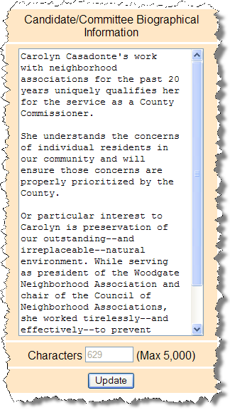
Be sure you conform to the Supervisor’s policy on appropriate content here.
The system will show you how many characters you’ve already typed, so you’ll know when you’re reaching the limit.
When finished, click Update.
Type the biographical data here.
Note When a candidate updates their bio for the first time, they will need to remove any html elements that might have been entered before the change. If no html elements were added then updates will happen as normal.
If you ever want to change the photo or bio, just return to the Candidate/Committee Bio page and upload a different photo or edit the bio text.
To see how your photo and bio appear to voters, enter this address in your web browser, replacing <county> with your county name:

https://www.voterfocus.com/ws/WScand/candidate_pr.php?c=duval
You will not see your photo and bio immediately. Our office reserve the right to review your information before it is released to the public on their website.

Reset Password
If you’ve forgotten your password, you can simply reset it by clicking the Forgot Password link on the Log In page.
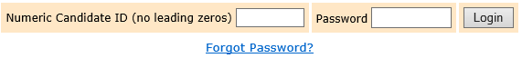
On the Candidate Forgot Password page, enter your Candidate ID number and click the Reset Password button.
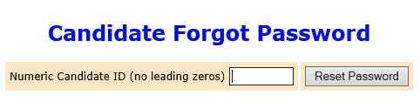
An email similar to the one below will be sent to the email address associated with your account.
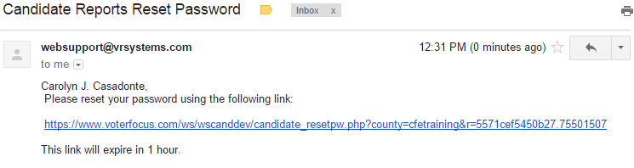
Click the link provided in the email.
field.

If for some reason there is not an email address associated with your Candidate ID, you’ll need to contact the Supervisor of Elections office.
On the Candidate Reset Password page:
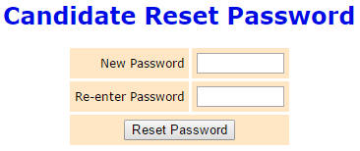
You’ll need to enter the same password in the Re-enter Password field to confirm the new password.
Enter a new password in the New Password field.

The password can be up to 12 characters—letters and/or numbers—and is case-sensitive.
Then click the Reset Password button and proceed back to the Log In page.

Change a Password or PINs
You can change the password assigned to you by the elections office, if you like. A password can be any combination of letters and numbers.
If your county required electronic filing of reports, your campaign has been issued PINs for the candidate and treasurer. You can also change these PINs, if you wish.
To change your password:
On the Report List, click Change Password/PINs.
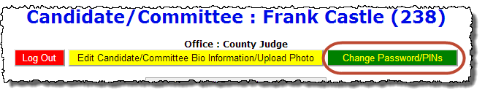
In the Enter Old Finance System Access Password field, enter your current password. You need to do this even if you don’t want to change the password, but only want to change one or both PINs.
If you want to create a new password, enter and reenter it in the two fields provided for the new password. The password can be up to 12 characters—letters and/or numbers—and is case-sensitive. If you don’t want to change your password, don’t make any changes to the password fields.
If you want to change a PIN, enter and reenter the new PIN in the two fields provided for the new PIN. Then enter your new password in the other two fields.
Click Change Password/PINs when you are finished.
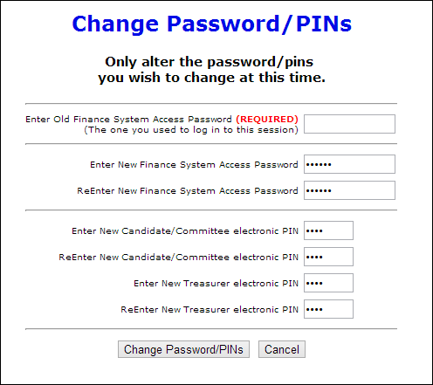
To finish changing the password and PINs, click here.
…and your new treasurer PIN here.
Type your new candidate PIN here…
Type your new password here.
Type your current password here.
From now on, you will log on with your new password. Keep in mind: if you set up the Candidate Log In page to automatically fill in your password, you will need to retype the password there the next time you log in. When you do, you might see this message:
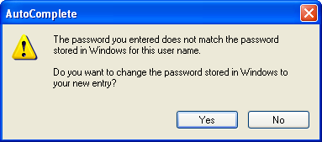
Simply click Yes to proceed into the Campaign Financial Reporting system.
Should you forget your new password, follow the instructions on page 59. If you forget your PINs, contact the elections office. They will be able to retrieve them for you.

Log Out of the System
When you are finished with a session on the Campaign Financial Reporting system, be sure to log out so that unauthorized persons cannot modify your report data.
To log out of the system:
On the Report List, click .
Click here to log out of the system.
