Using Data Files from the Supervisor of Elections
Jerry Holland
Duval County Supervisor of Elections
105 East Monroe Street
Jacksonville, FL 32202

Last Updated: Thursday, July 20, 2023
The content of this document is confidential and a proprietary trade secret. It is therefore not subject to open disclosure under Florida Public Records laws.
This document was prepared in part using material provided to Duval County by VR Systems Inc. Such material is confidential and a proprietary trade secret. The software is also a proprietary trade secret. Software and software documentation are therefore not subject to open disclosure under Florida Public Records laws.
The information in this document is subject to change without notice. No part of this document may be reproduced or transmitted in any form or by any means, electronic or mechanical, for any purpose, without the express written permission of VR Systems Inc.
© 1995-2021 VR Systems Inc. All rights reserved.

CONTENTS

Data Available from Your Supervisor of Elections Error! Bookmark not defined.
Candidate Label Export File 5
Text File of Voters With or Without Voting History 6
Daily Election Files 10
Absentee Ballot Request Information File 10
Early Voting Summary Error! Bookmark not defined.
Early Voting Voters List 12
Loading the File Into Excel 13
Using Microsoft Word to Create Mailing Labels 15
Loading a File Into Microsoft Access 20

Data Available from Your Supervisor of Elections

Data to Request from  Supervisor | Delivery  Formats
Mailing Labels for Vote-by Mail voters  (sometimes called “Candidate Labels” or “Absentee Labels”) | Printed labels
Text File of Voters with or without Voting History (You can request a  list of all voters or just the voters  requesting mail ballots for a  specific election. | Email
Walking List of Voters in Door-to-Door  Order | Printed list; Email
Mailing Labels for Voters meeting  Specific criteria | Printed labels; Email
Daily Election Files sent to the State:  Absentee Ballot Request Information File  Early Voting Voters List | Files posted to “Candidate Files” and retrieved  on our website
Get Out the Vote Report | Email; Posted to “Candidate Files” and retrieved on our website

Candidate Label Export File
The Candidate Label Export File lists voters who have requested a mail ballot for an election. It is a comma-delimited text file that can be imported into applications such as Excel, Word, and Access. Consult the product documentation for instructions on employing the file for your needs.
The following table describes the fields in the Candidate Label Export file. Your file might not include all fields described here. The quote (") character is used as the text qualifier.

Field Name | Description
Voter ID | Unique voter registration ID number
Party | Voter’s political party affiliation
Precinct | Voter’s precinct
ABS_Mil_Civ | Whether the voter is military or civilian. (Military includes voters marked as military dependents.
Sex | M – Male, F – Female, U - Unknown
Race | 1 – American Indian/Alaskan  2 – Asian or Pacific Islander  3 – Black, not Hispanic  4 – Hispanic  5 – White, not Hispanic  6 – Other  7 – Multi-racial  9 – Voter did not specify their race
Zip_Code | Zip code of residential address
Phone | Voter’s telephone number with area code
Name | Voter’s name
Email | Voter’s email address
Address1 | First line of mailing address
Address2 | Second line of mailing address
Address3 | Any additional line for an overseas address
Address4 | Any additional line for an overseas address

Text File of Voters With or Without Voting History
This voter list is a comma-delimited text file, meaning that each field is separated by a comma. Each data field retrieved from a voter’s record is enclosed in double-quotes ("). If there is no data available for a field (say, the voter's address does not have an apartment number), you will see a set of empty double-quotes followed by a comma, like this:
"",
The file can be imported into a variety of office applications such as Excel, Word, and Access from Microsoft®. Consult the product documentation for instructions on using the file for your needs.
Field Name | Description
VoterID | Unique voter registration ID number
Voter_Name | Last name, name style (SR, JR, III, etc) first name, middle initial
Last_Name | Last name
First_Name | First name
Middle_Name | Middle name
Name_Style | Name style (SR, JR, III, etc)
Formatted_Address | First line of the mailing address. If the voter has no mailing address, this field contains the first line of the residential address.  The address is formatted on one line using the street number, street number suffix, apartment number. For example:  2345A S MONROE ST 67B  Where A is the street number suffix, S is the street direction, and 67B is the apartment number.  For a street with a direction suffix, the address might be:  4234B SHAMROCK RD E
City_State | City and state of address used in Formatted_Address
Zip_Country | Zip/postal code and/or country of the address used in Formatted_Address
Residence_Address | Street address line of residential address
Street_Number | Street number of residence address
Street_Number_Suffix | Street number suffix of residence address
Street_Dir | Street direction of residence address
Street_Name | Street name of residence address
Street_Type | Street type of residence address
Street_Dir_Suffix | Street direction suffix of residence address
Unit_Type | The type of unit, such as APT or BLDG
Apartment_Number | Apartment number of residence address
Zip_Code | Zip code of residence address
City_Name | City name of residence address
Mailing_Address_1 | The first line of the voter address. This is not necessarily the voter’s mailing address. The address used here depends on whether you requested a list of all voters or only the voters who have requested a mail ballot for a specific election:  Voter List – This field contains the mailing address. If the voter record has no mailing address, the residential address is used instead.  Absentee Requests – This field contains the first one of the following addresses found in the voter record:  - A one-time address for this election’s ballot  - The address for all mail ballots to this voter in every election where they’ve requested a mail ballot  - The mailing address  - The residential address
Mailing_Address_2 | Second line of the address used in Mailing_Address_1
Mailing_Address_3 | Third line of the address used in Mailing_Address_1. If the address does not have an entry in Line 3, the city, state and zip will be consolidated in this field.
Mailing_Address_4 | If voter’s address used in Mailing_Address_1 has a value in the Country field, the value will be inserted in this field.
Mailing_City | City of the address used in Mailing_Address_1
Mailing_State | State of the address used in Mailing_Address_1
Mailing_Zip | Zip or postal code of the address used in Mailing_Address_1.
Mailing_Country | Country of the address used in Mailing_Address_1.
Race | 1 – American Indian/Alaskan  2 – Asian or Pacific Islander  3 – Black, not Hispanic  4 – Hispanic  5 – White, not Hispanic  6 – Multiple races or a race not listed  9 – Voter did not specify their race
Sex | M – Male  F – Female  U - Unknown
Birth_Date | Date of voter’s birth in MM/DD/YYYY format
Registration_Date | Date voter registered to vote in MM/DD/YYYY format
Congressional_District | Voter’s US Congressional district
Party | Voter’s political party affiliation. For example:  DEM – Democrat  REP – Republican  NPA – No Party Affiliation
Precinct | Voter’s precinct
House_District | Voter’s Florida House district
Senate_District | Voter’s Florida Senate district
Commission_District | Voter’s county commission district (City Council district)
School_Board_District | Voter’s school board district
Assistance_Required | Y – assistance required to vote  N – assistance not required
Mailing_Address_Flag | Y if the voter has a mailing address.
City_Code | 1 – Atlantic Beach  2 – Baldwin  3 – Jacksonville Beach  4 – Neptune Beach
City_Ward | 1 – Jacksonville Beach District 1  2 – Jacksonville Beach District 2  3 – Jacksonville Beach District 3
Telephone_Number | Voter’s telephone number with area code
Voter Status | Voter’s registration status
Email_Address | Voter’s email address, if present in their record.
20 voting-history fields | Appear only if you requested that the file include voting-history data

The following codes are used in the voting-history fields to specify whether and how the voter voted.
Y | Voted at the polls
Z | Voted at the polls by provisional ballot (ballot was tabulated)
N | Did not vote
A | Voted by mail (includes referred ballots that were tabulated)
B | Mail ballot not counted (not tabulated)
P | Provisional ballot rejected by canvassing board (not tabulated)
X | Ineligible to vote
E | Early voted
F | Early voted by provisional ballot (ballot was tabulated)
<blank> | Not registered at the time of the election or information not available
In elections prior to 2006, the codes B and P were not used. B was included in Y and P was included in N. Early voting began in 2004; the first election in which you will see the code E is the 2004 General Election.
The codes F and Z were introduced in early 2010 to represent provisional ballots marked at early voting sites and the polls, respectively, which were later tabulated. Prior to implementation of these two codes, tabulated provisional ballots were included in codes Y (for provisional ballots at the polls) and E (provisional ballots at early voting).

Daily Election Files

Absentee Ballot Request Information File
This text file is a State-required list of county voters who have requested a mail ballot for an election, the status of the request, and other relevant data. Voters with protected addresses are excluded from the file.
The file is sent to the State system daily beginning 60 days prior to an election and ending on the 15th day after the election. If a general election is preceded by a primary, a separate file is sent for each election.
The file contains information processed up to close of business on the day prior to the daily run. Each daily file contains all vote-by-mail voters to date, not just new additions. It can contain vote-by-mail data for multiple elections.
The file name is:
<county ID>_ABL_<FVRS election number>_<date of run>_<time of run>.txt
Contents of the File
CountyID (DUV)
DUV
VoterIDNumber
9-digit number
ElectionNumber
ElectionDate
ElectionName
LastRecordChgDate (Date absentee summary record last updated)
VoteByMail (Status)
C: Voter canceled a request for vote-by-mail ballot.
E: Voter-caused error in a returned vote-by-mail ballot other than a failure to sign the Voter’s Certificate.
N: Voter returned a vote-by-mail ballot with
no signature on the Voter’s Certificate.
P: Vote-by-mail ballot is provided to the voter by any proper means of delivery (mail, fax, etc.).
R: Supervisor of Elections has processed vote-by- mail ballot request and determined that the voter is eligible to vote-by-mail for that election.
S: Voter has or makes a standing request to receive a vote-by-mail ballot for all elections occurring from the date of the request through the end of the calendar year for the second ensuing regularly scheduled general election. (Once the supervisor determines that the voter is eligible to vote-by-mail in a particular election, the status of the standing request for that election is recorded as “R.”)
U: Vote-by-mail ballot is returned as undeliverable to the address where it was sent.
V: Voted vote-by-mail ballot is returned and received in the supervisor’s office and does not otherwise fall into a status code of E, N, or U.

RequestDate
DeliveryDate
BallotReturnDate
ReqCanceledDate
Military
OverseasFlag
MilitaryDependent
Precinct
Precinct Split
CongressionalDistrict
SenateDistrict
HouseDistrict
CountyCommissionerDistrict (City Council District)
City Council District
SchoolBoardDistrict
OtherDistrict
Party
VoterName
ReqMailingAddressLine1
ReqMailingAddressLine2
ReqMailingAddressLine 3
ReqMailingAddressCity
ReqMailingAddressState
ReqMailingAddressZip
ReqMailingAddressCountry
ReqE-mailAddress
ReqFaxnumber
Note: The absentee request status S denotes voters who have a standing request for a mail ballot in all elections, while R denotes voters who requested a mail ballot for this election only. When vote-by-mail requests are generated for all-elections voters, all S voters who are eligible to vote in the election subsequently appear twice in the Absentee Ballot Request Information file, appearing once with the S status and again with the R status. Any all-elections/FPCA voters who are not eligible to vote in the election appear with the S status and are only listed once. Those voters are not listed again with an R status, since they will not receive a ballot.

Early Voting Voters List
This State-required text file lists county voters who have early voted in an election to date. The file is sent to the State system daily beginning the Tuesday after the Monday when early voting begins and ending the day after early voting finishes. If multiple elections have early voting in progress on a given day, a separate file for each election is sent to the State.
The file name is:
<county ID>_EVL_<FVRS election number>_<date of run>_<time of run>.txt
Contents of the File
County ID
FVRS election number
Election date
Election name
Voter registration ID
Voter name
Precinct
Precinct Split
Congressional District

Senate District
House District
County Commission District (City Council District)
School Board District
Other District
Party
Voter’s early voting location
Date voter early voted

Loading the File Into Excel
- In Excel, select File > Open and select the file provided by the Supervisor of Elections.
- On the first dialog of the Text Import Wizard, select Delimited and click Next.
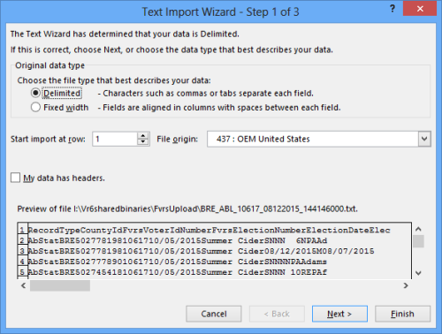

3. On the second dialog, under Delimiters, select one of the following:
  - Tab—if the file does not contain commas.
  - Comma— if the file has commas between the data elements.
If you aren’t sure which delimiter to use, select the one that logically separates the data in Excel’s Data Preview pane so it looks like the example here.
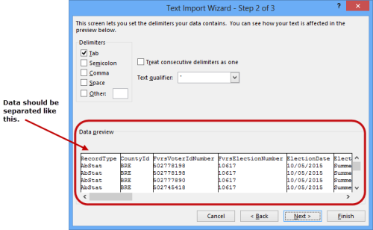
- Clear the other check boxes in the Delimiters box.
- For the Text Qualifier, select the double-quote character (“), and then click Next.
The third dialog of the wizard shows the data format at the top of each column. By default, all columns are formatted as General, which aligns all fields to the left.
- You can change the format of any column by clicking in the column and selecting a different format in the Column data format box. You might, for example, want to change data fields to a Date format, as shown in the example here:
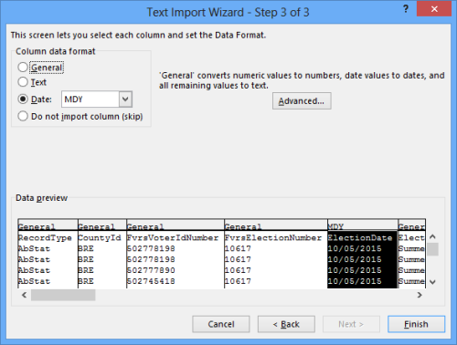
- Click Finish to load the file in an Excel worksheet.
If you plan to create mailing labels using the mail merge capability in Microsoft Word, save the Excel worksheet as a text (TXT) file.

Using Microsoft Word to Create Mailing Labels
- In Word, open a new blank document.
- On the Word ribbon, click Mailings.
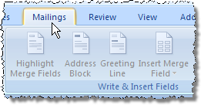
- Click Start Mail Merge > Labels.
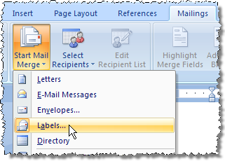
- On the Label Options dialog, select the type of printer you have—either Continuous-feed or Page printer—and the tray where your blank labels are loaded.
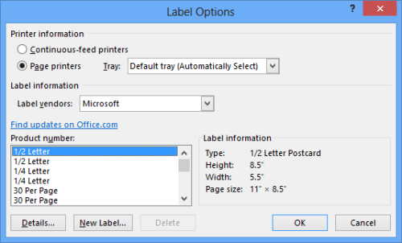
- In the Label vendors field, select your label vendor from the drop-down list.
- In the Product number field, select the label size.
- Click OK to display a grid sized for your mailing labels.
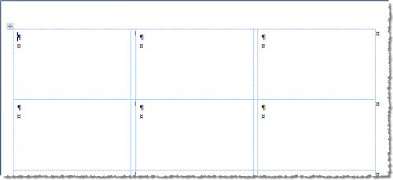
- Click Select Recipients > Use an Existing List.
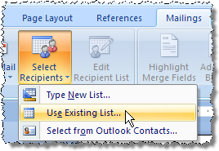
- On the Select Data Source dialog, navigate to the text file you saved in Excel and click Open.
- Verify that the cursor is in the first label box (that is, the top left box on the page).
- Click Insert Merge Field and, on the list that appears, click the field you want to appear in the first line of the label. (Typically, this is the voter name.)
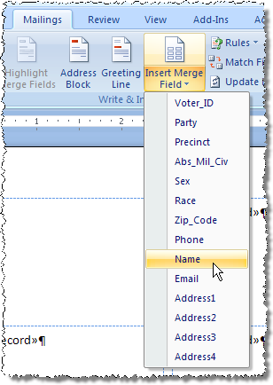
The data field you selected will appear in the first label box.
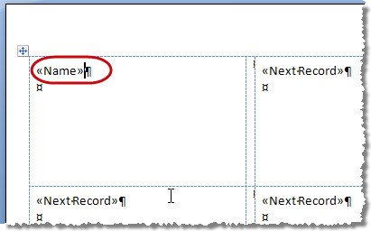
- Repeat the previous step for all fields you want on the label. Remember to format the label by inserting returns and spaces so that the fields won’t run together. Here is an example of a finished label layout.
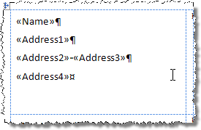
- After you insert all the fields for the label layout and the layout is formatted properly, click Update Labels to fill the other blocks in the grid with the layout in the first block.
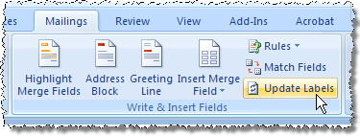
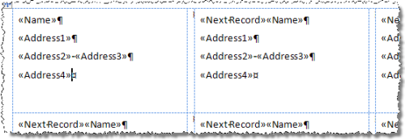
- Click Preview Results.
The label grid is populated with the voter data from the text file (that is, the “recipients list”).
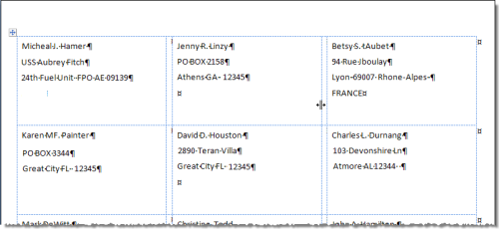
- Use the arrows in the Preview Results box on the toolbar to scroll through the labels to verify the layout looks good.
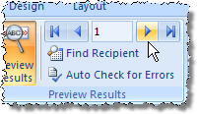
- When you are ready to print, click Finish & Merge > Print Documents.
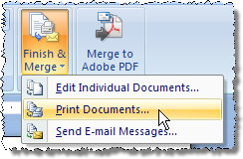
- Select your printer and click OK to print the labels.

Loading a File Into Microsoft Access
- In Access, click File > Open.
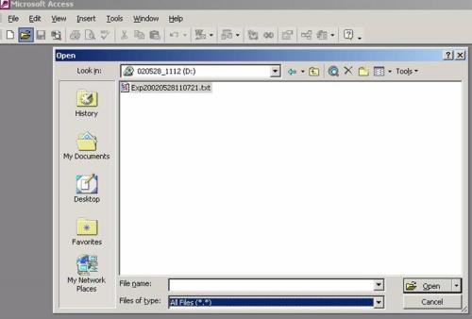
- At the top of the Open dialog, in the Look In field, select the folder where the file provided by the Supervisor of Elections is located.
- In the Files of type field select All Files.
- Highlight the text file and click Open.
- On the first dialog of the Link Text Wizard, select Delimited and click Next.
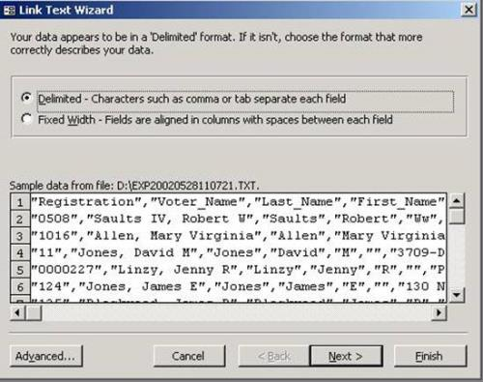
- On the next dialog of the wizard, select Tab or Comma and click Next.
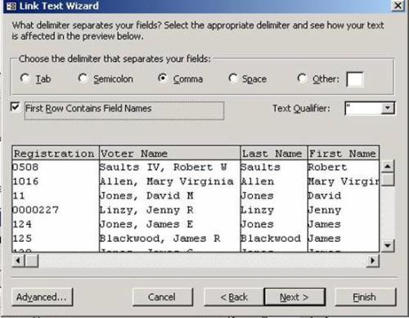
- Examine the first line of the file. If it contains header information rather than individual voter data, select First Row Contains Field Names. and click Next.
- The next dialog displays the name of each field and its data type. Using the bar across the bottom you can move through the fields. You might want to change the data type of date fields like Birth_Date to Date/Time, as shown here. Click Next.
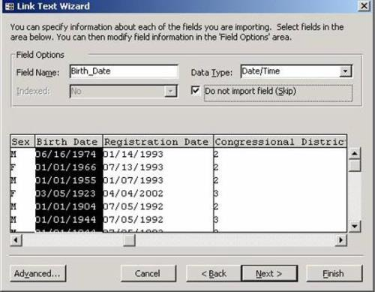
- Enter a name for your Access table and click Finish.
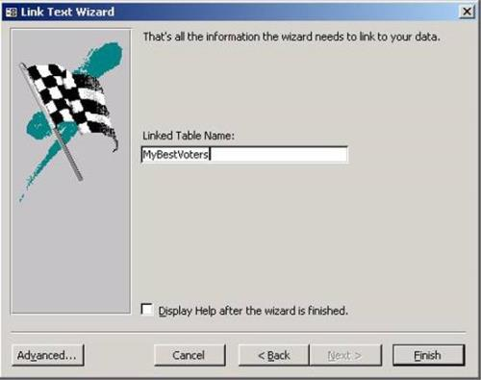
The data is imported into Access and is ready for use.

